2024 Bill of Rights & Amendments
Please note that the only Amendments that will have questions
are those with pictures.

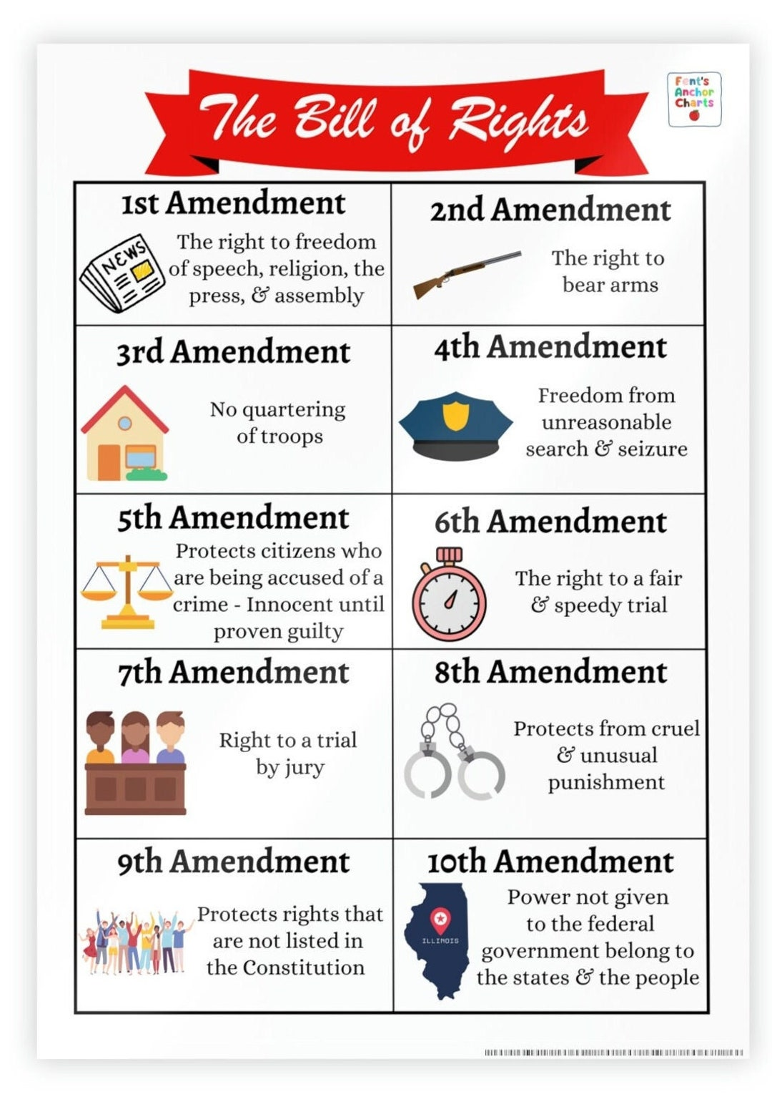

How many Amendments are in the Bill of Rights?
There are 10 amendments that make clear what the limited powers of the Federal government are and what the government must protect.
What rights does Amendment 1 protect?
It states Congress cannot make any laws restricting our rights to freedom of religion, speech, press, redress or assemble.
This means that Congress must protect our right to:
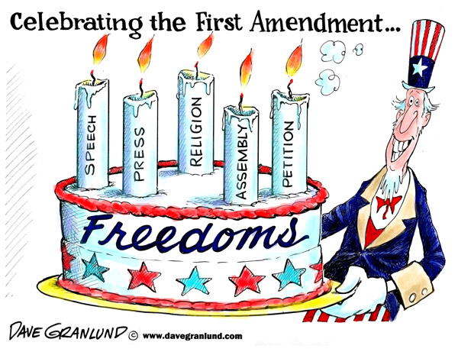
- Religion: exercise your religion & faith or conscience without prohibition.
- Speech: speak our minds & say what we want, even if others do not like it.
- Press: free press that can circulate news, even if it is unfavorable to those holding positions.
- Asembly: gather or meet in groups.
- Redress: petition the government to be heard & express concerns when they feel justice has not been served.

Freedom of Religion The Pilgrims and Puritans did not have religious liberty in England and suffered great persecution for their beliefs. The Founders believed that no one could be free without religious liberty and the right of conscience.
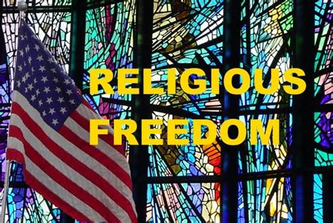

"The Religion then of every man must be left to the conviction and conscience of every man: and it is the right of every man to exercise it as these may dictate." —James Madison, 1785.

Freedom of Speech The Founders were not allowed to speak against the king without suffering serious consequences. They wanted to protect peoples’ right to speak openly about issues and concerns they had with the government and others. Does that mean that people have a right to use hate speech? What about saying things that make others feel bad or don’t like?
Why do we need protection of speech if you can only say things that others like? The point of free speech is to be able to discuss and debate every idea without fear of reprisal.
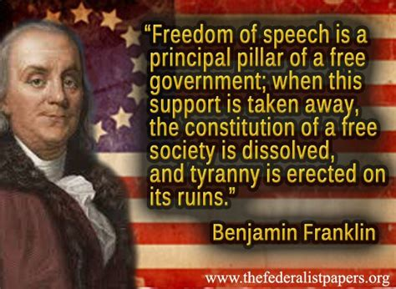
"Driven from every other corner of the earth, freedom of thought and the right of private judgment in matters of conscience direct their course to this happy country as their last asylum." —Samuel Adams, Speech on August 1, 1776.
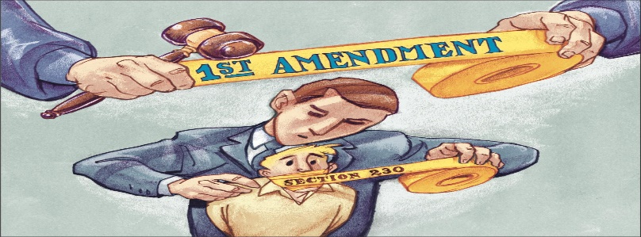

Freedom of the Press This freedom allows people to publish their opinions and information without the government stopping them. This may be through any type of media including the newspaper, radio, TV, printed pamphlets, or online. This does not allow one to take the freedom of others by publishing or printing lies about people to damage their reputation (this is called defamation) or copying someone else’s work (copyright law).
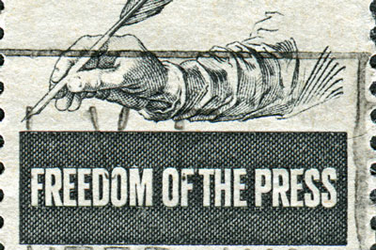
"While we are contending for our own liberty, we should be very cautious not to violate the conscience of others, ever considering that God alone is the judge of the hearts of men, and to Him only in this case are they answerable." —George Washington, in a letter to Benedict Arnold.
Right to Assemble This freedom gives people the right to gather in groups as long as they are peaceable. The government must allow people to gather on public property. This allows people to hold protests and rallies against the government calling for changes. In some cases, the government may get involved in order to protect the safety of the citizens. Permits may be required to hold large protests, but the requirements for the permits cannot be too difficult to meet and must be required for all organizations, not just some of them.
"Conscience is the most sacred of all property." —James Madison, 1792.
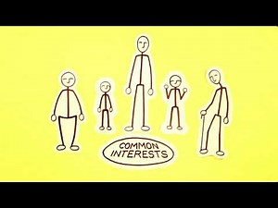

Right to Redress or Petition the Government The right to petition the government was important enough to the Founding Fathers to include in the First Amendment. They wanted a way for the people to officially bring issues to the government. This right allows individuals or special interest groups to lobby the government & sue the government if they feel they were wronged.
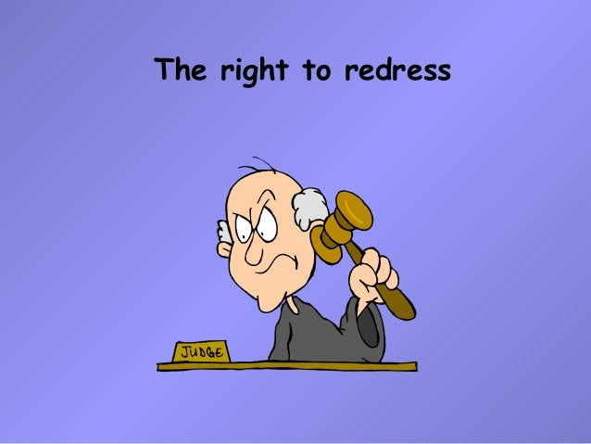

What rights does Amendment 2 protect?
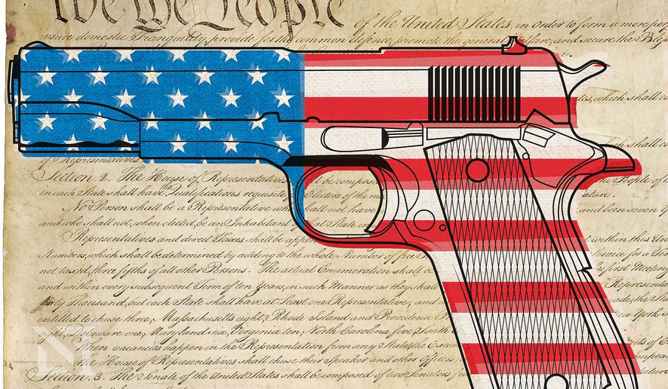
It states that it is essential to our liberty to have a well regulated Militia and forbids Congress from passing any laws that infringe on the rights of the people to keep and bear arms or guns.
CONTEXT: It was the citizen farmers that had to defend themselves against their own government when the British soldiers marched from Boston Harbor to Lexington and Concord and opened fire against them known as “The shot heard around the world”. They understood that freedom could only be held by the people if they had the power to defend themselves with the same power the government had so they wanted to be sure that power could never be taken from the people.

What rights does Amendment 3 protect?
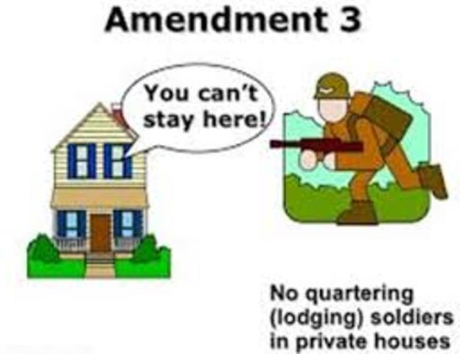
It states No soldiers shall be quartered, or housed in your home without your permission. During the war Soldiers would move in and take over the Colonists homes without the permission of the homeowners because they were under the control of the King.
What rights does Amendment 4 protect?
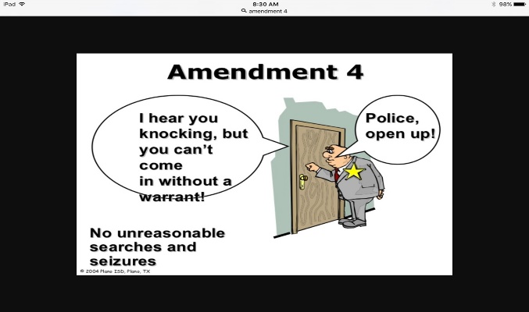
People have the right to privacy in their -
- homes,
- papers,
- effects (all their stuff) and their
- persons - the government can't search you, your body, or your stuff without your consent or a search warrant.

What rights does Amendment 5 protect?

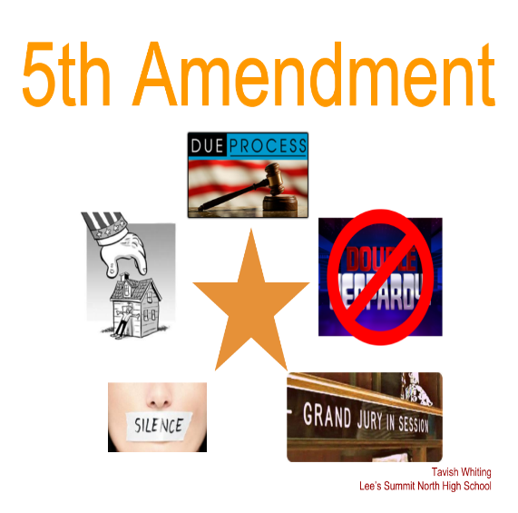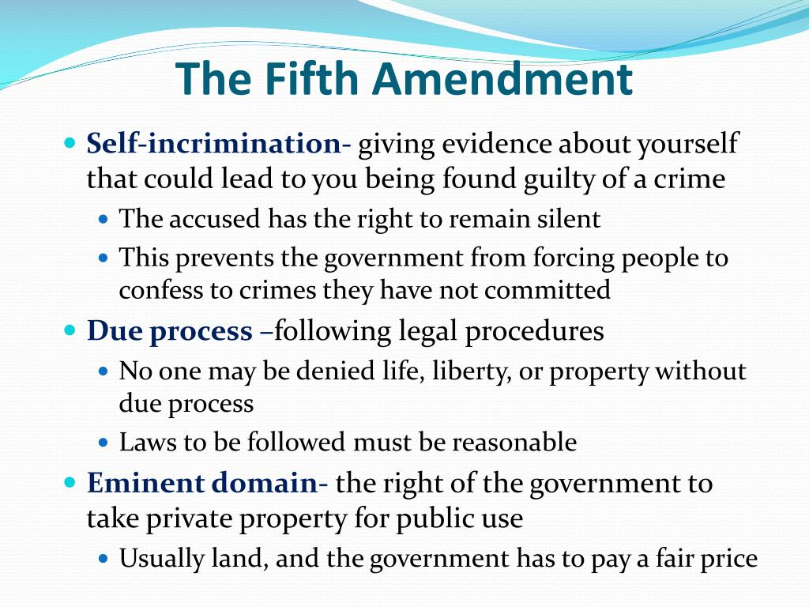
It is the protection of rights in criminal cases. No double jeopardy, a person can't be tried twice for the same crime, you don't have to testify against yourself, everyone gets due process, the government can't take your property without compensating you for it.
What rights does Amendment 6 protect?
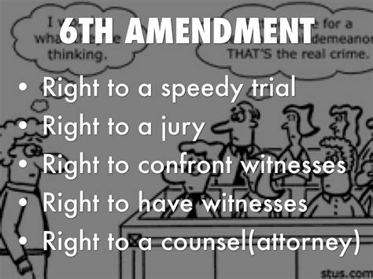
It gives protection in criminal cases. Everyone is entitled to a speedy trial by a jury of peers, the right to be told what crime they are being accused of, and be able to meet and answer the accuser, as well as to be able to obtain witnesses in their favor and to have a lawyer defend one's self.

What rights does Amendment 7 protect?
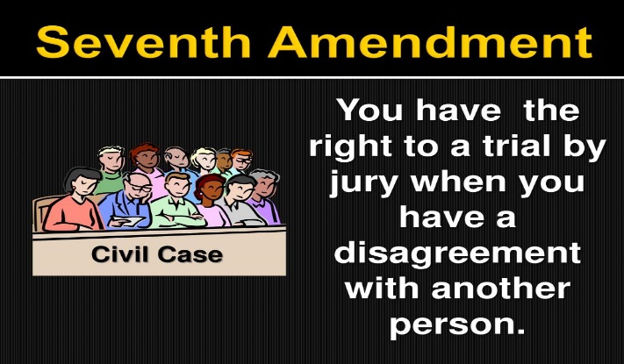
Protection of rights in civil cases and trial by jury.
What rights does Amendment 8 protect?
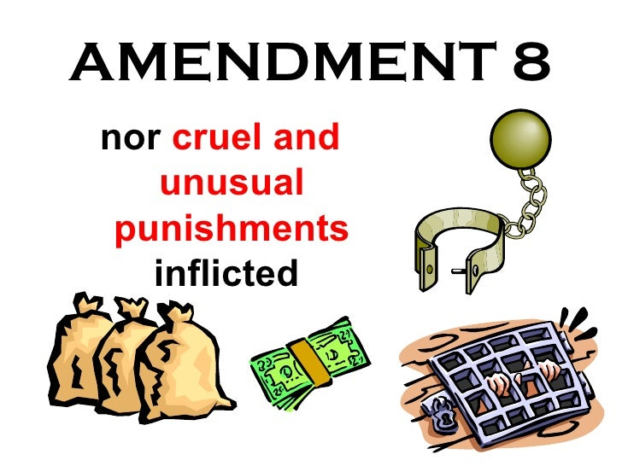 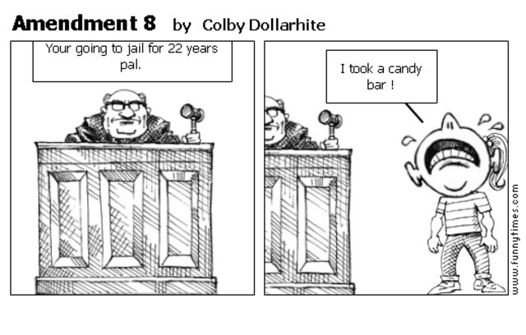Protection from excessive bail or fines, and any cruel or unusual punishment.

What rights does Amendment 9 protect?
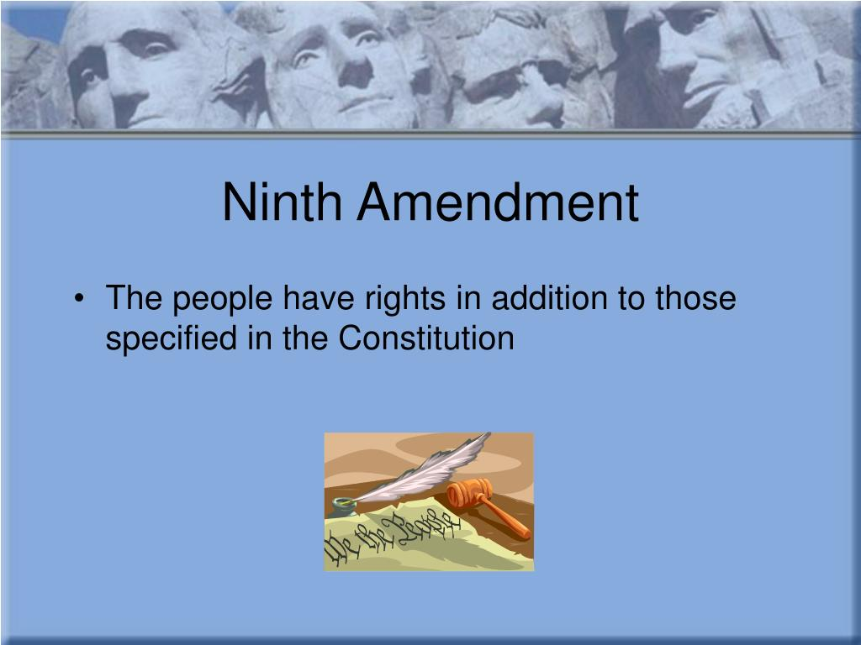
Rights are retained by the people even if they are not mentioned, listed or referred to in the Constitution or the Bill of Rights.
Just because a right is not mentioned in the Constitution or the Bill of Rights, does not mean the people do not have it, the rights are retained by the people regardless.
What rights does Amendment 10 protect?
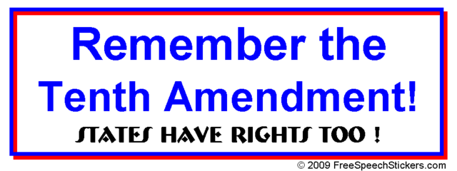
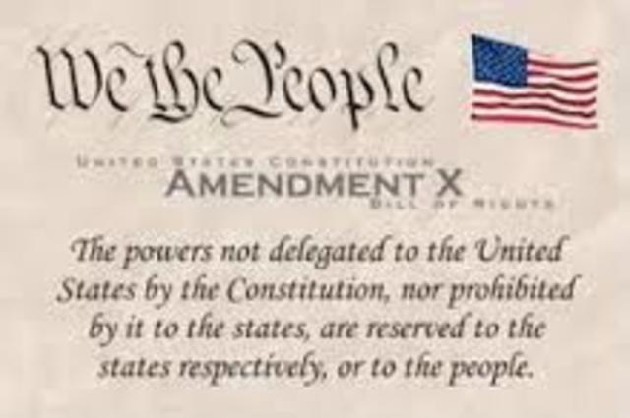
All powers that are not specifically delegated to the federal government, or not specifically prohibited to the states, are the powers of the states and the people.
There are 27 amendments which means that the Constitution has been changed 17 times. No, not 27 times, because the Bill of Rights did not change the Constitution, it did not list the rights of the people. It clearly forbids the federal government from passing laws restricting these rights.
Amendment 11 - Prohibits the federal courts from hearing certain lawsuits against states.
Amendment 12 - Changed the Vice President from being elected by the second highest vote

Amendment 13 - Ended slavery! Finally!
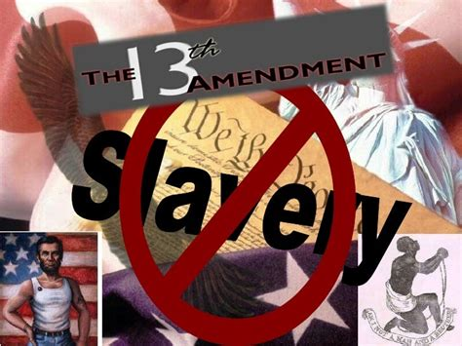

Amendment 14 - Protection of civil rights for all
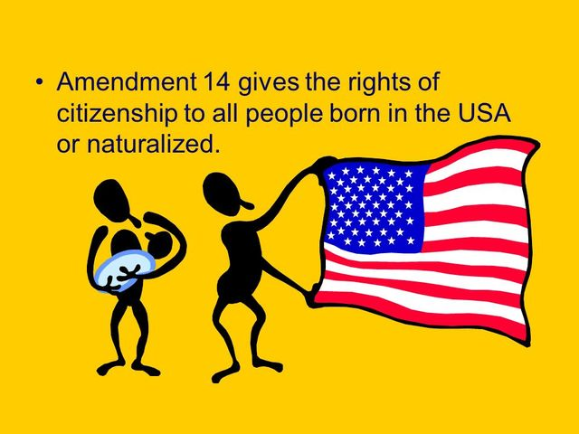

Amendment 15 - Forbids racial discrimination in voting.
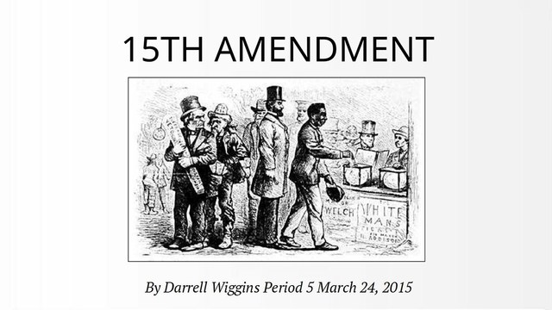

Amendment 16 - Congress imposes income tax directly to citizens.
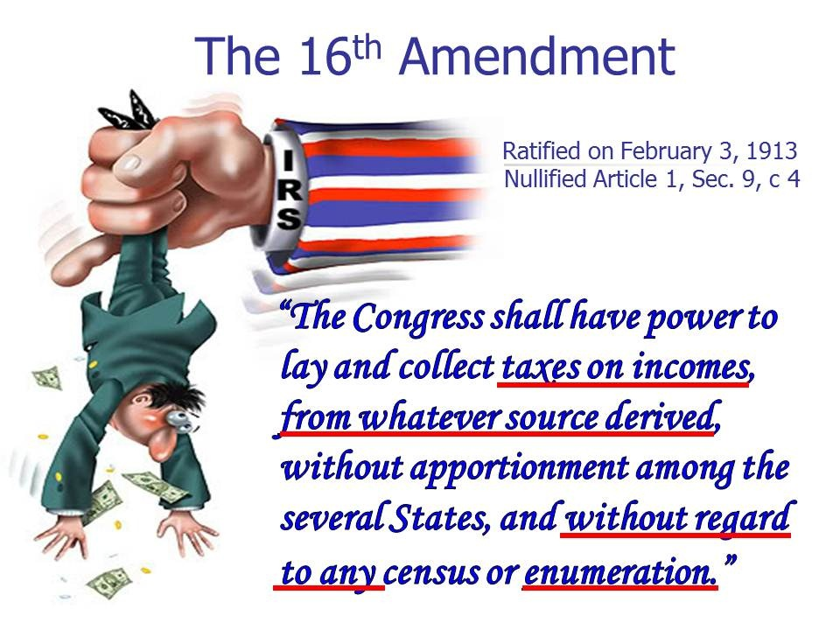

Amendment 17 - Changes the way Senators are elected from being elected by the state legislators to being elected by the citizens.
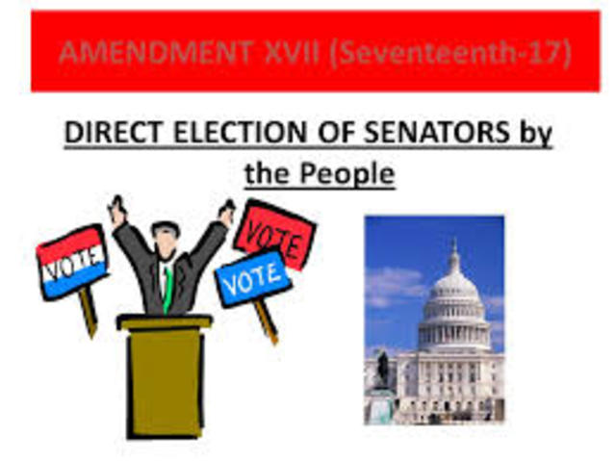
Amendment 18 - Prohibition, the manufacture, sale and transport of alcoholic beverages.
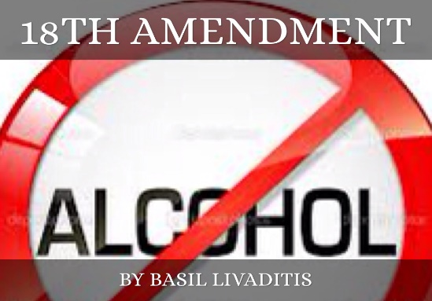

Amendment 19 - Women’s suffrage
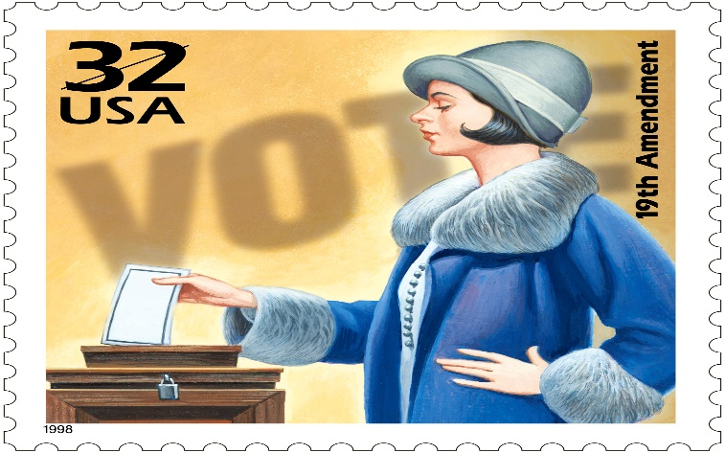

Amendment 20 - Sets the dates at which federal government elected offices end and also defines who succeeds the president if the president dies.
Amendment 21 - Repeals the 18th amendment, and the prohibition of alcohol .
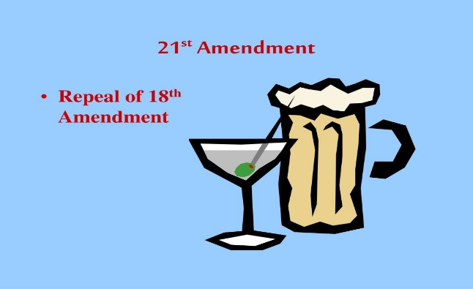

Amendment 22 - President cannot run more than 2 terms
Amendment 23 - Allows Washington DC to have electors to vote for President
Amendment 24 - Instituting the popular vote for President
Amendment 25 - Allows the Vice President to become the President in the event of death, resignation, removal from office or impairment that prevents the current president from fulfilling his or her duties.
Amendment 26 - Changes the voting age from 21 to age 18 yrs old. During WWII, President Franklin Roosevelt lowered the minimum age for the military draft to 18 thus the slogan - “Old enough to fight, old enough to vote”.
Amendment 27 - Prohibits any law that changes the salary of Congress from taking effect until following the start of the next election.

