2024 Freedom’s Light Constitution Bee Study Guide
Declaration of Independence
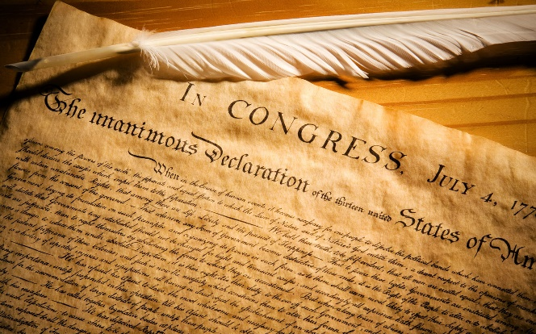
What does the Declaration of Independence do?
The Declaration of Independence is one of the most amazing documents in all of history! Written mostly by Thomas Jefferson, this document (1) declares America was going to be an independent nation from England and would no longer be under the rule of King George III, (2) it gives the reasons they were declaring their independence, and (3) it lists their 27 grievances against the British government.
Every principle in the Constitution is found in the Declaration.
As Jefferson said, ”The law should restrain men from injuring one another but leave them otherwise free to regulate their own pursuits.”
Why is it so important?
The Declaration and Constitution are based on the Laws of Nature and Nature's God. The founders knew we needed our laws based on what they called “right reason aligned with nature”, based on a moral compass and based on a foundation that is universal, unchanging and everlasting, not determined by men’s passions.
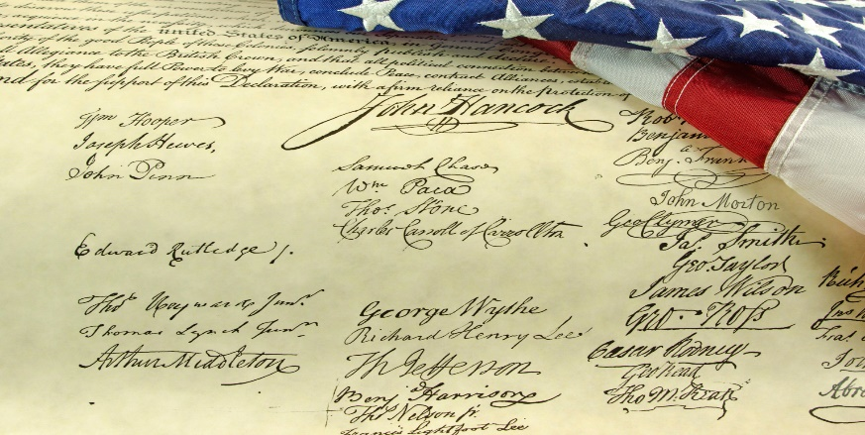
What are the 8 principles of freedom and liberty that Jefferson put in the first 2 paragraphs of the Declaration?
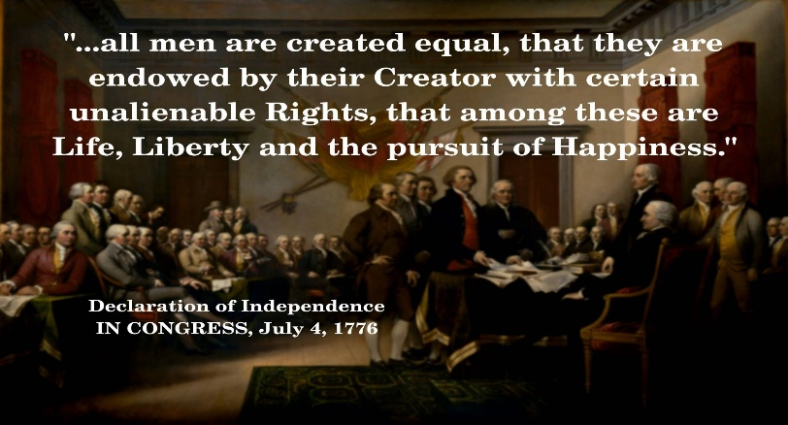
The role of the government is to protect the rights of the people.
Each person is equal in rights, justice, value & protection
Rights come from our Creator
Rights are unalienable.
Each have right to life, liberty and property ownership
Self government
Established on the laws of Nature & Nature’s God
Founded on Self-evident truths
Power lies in the consent of the people (governed)

Thomas Jefferson put the following passage in the original Declaration, but it was taken out because of great protest from several states that engaged in slavery.
“He has waged cruel war against human nature itself, violating its most sacred rights of life and liberty in the persons of a distant people who never offended him, captivating & carrying them into slavery in another hemisphere or to incur miserable death in their transportation thither.
He is now exciting those very people to rise in arms among us, and to purchase that liberty of which he has deprived them, by murdering the people on whom he has obtruded them: thus paying off former crimes committed again the Liberties of one people, with crimes which he urges them to commit against the lives of another.”

According to the Declaration -
What is the proper role of the Government?
To protect the freedoms of the people.
Who is supposed to govern us?
America is founded on Self Government.

Which people are entitled to special rights?
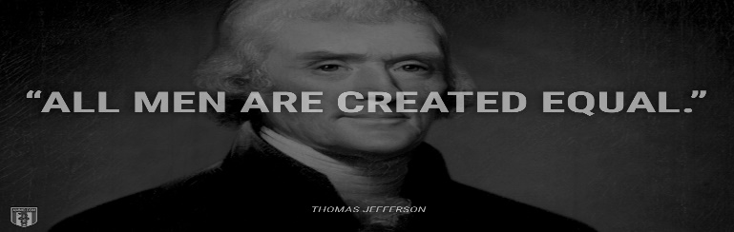All men are created equal, not the same, but equal in value and treatment.

Who gets to have extra protection or justice from the government?
We are all equal in rights, justice and equal protection.
Who has the power to take our rights away?
Because our rights come from the Creator, they are inalienable and can’t be taken without the offender coming under judgment of the Creator.
What are our unalienable rights?
Most notable unalienable rights are Life, Liberty, and property ownership, pursuing one's talents and potential.
Who was the first to sign the Declaration and why?
It was signed first by John Hancock, and he signed his name large enough so the King of England could read it without his spectacles!

The founders studied history, philosophy and the different forms of government that had been used to rule over people around the world. They chose a Republic over all other forms of government including a democracy!

According to the Declaration of Independence our rights come from our Creator. This is important because it is stating that since man does not give us our liberties man does not have the power to take them away.

There are 4 places that refer to the divine power of the Creator.

After the completion of the Constitutional Convention, Dr Benjamin Franklin was asked by Mrs. Powell who was standing near, “Well doctor, What have you given us, a republic or a monarchy?” Dr Franklin answered, “A Republic, ma’am, if you can keep it.”

The purpose of the Constitution is to limit the powers of the Federal government, and to list the power it has specifically. The only place in the Constitution that the federal government requires the states (that created it) to do something is in Article 4 Section 4. It requires every state to provide a ‘REPUBLICAN” form of government.

There are 2 things that both a Republic and a Democracy have in common. They are both ruled by the people, and both elect representatives.
There are several important differences between a Republic and a Democracy:
A Republic:
is governed by the rule of law.
has a written Constitution that protects the rights of every individual regardless of station or status.
elected officials take an oath to uphold the Constitution, the rule of law.
protects the minority so the majority cannot take away the unalienable rights of anyone.
A Democracy:
is ruled by the majority of people, also known as “Mob rule.”
only protects the rights of the majority, there is no protection for the rights of the minority.
is rule by the majority so the majority has the power to take the liberties away from the minority.
the individual or any group of individuals that are in a minority have no protection against the unlimited power of the majority.
There is no need for an oath because the people are not ruled by law nor by principle, they are ruled by the changing and fluid will of the majority or mob.

The Preamble to the U.S. Constitution
What is the Preamble?
The preamble is a summary of the purpose of the Constitution and the intentions the Founders established for the people both then and now:
To form a more perfect union
To establish justice
To insure domestic tranquility
To provide for the common defense
To promote the general welfare
Secure the blessings of liberty to ourselves and our posterity
When a law is passed, the law makers should ask themselves, “Do I have a right to use force against my neighbor to achieve this goal? “Would I be willing to forcibly take his property, or lock him in jail for failing to obey this law? If not, he should vote against it.

ARTICLES 1-3

The U.S. Constitution Articles 1, 2, 3
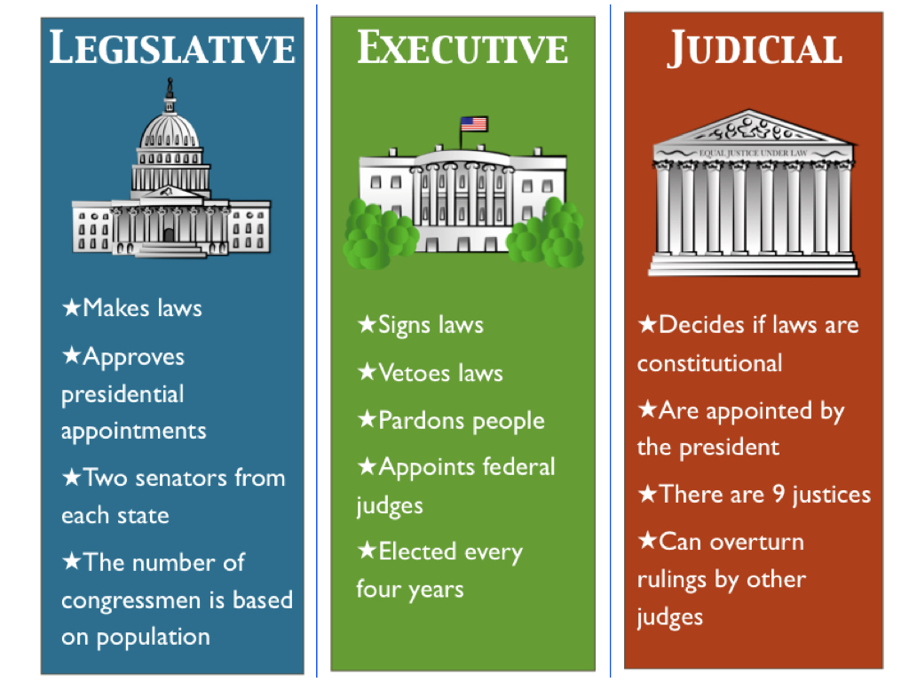

What is the role of the Constitution?
To protect the individual rights of the people.
The genius of the Constitution is the principles in it, including Federalism, the separation of power and checks & balances.

What form of Government did the Founders create?
A Republic, not a Democracy.
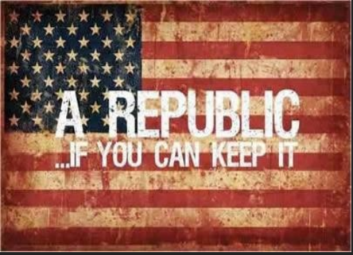
Who created the Federal government?
The Constitution & the federal government were created by the states to protect the rights of every individual. It is the foundation of America’s guiding principles that created the most prosperous and free nation in the world.
It is the supreme law of the land by which the federal government is bound and government officials in every state are bound.

One of the most important founding principles of the Constitution is Federalism! 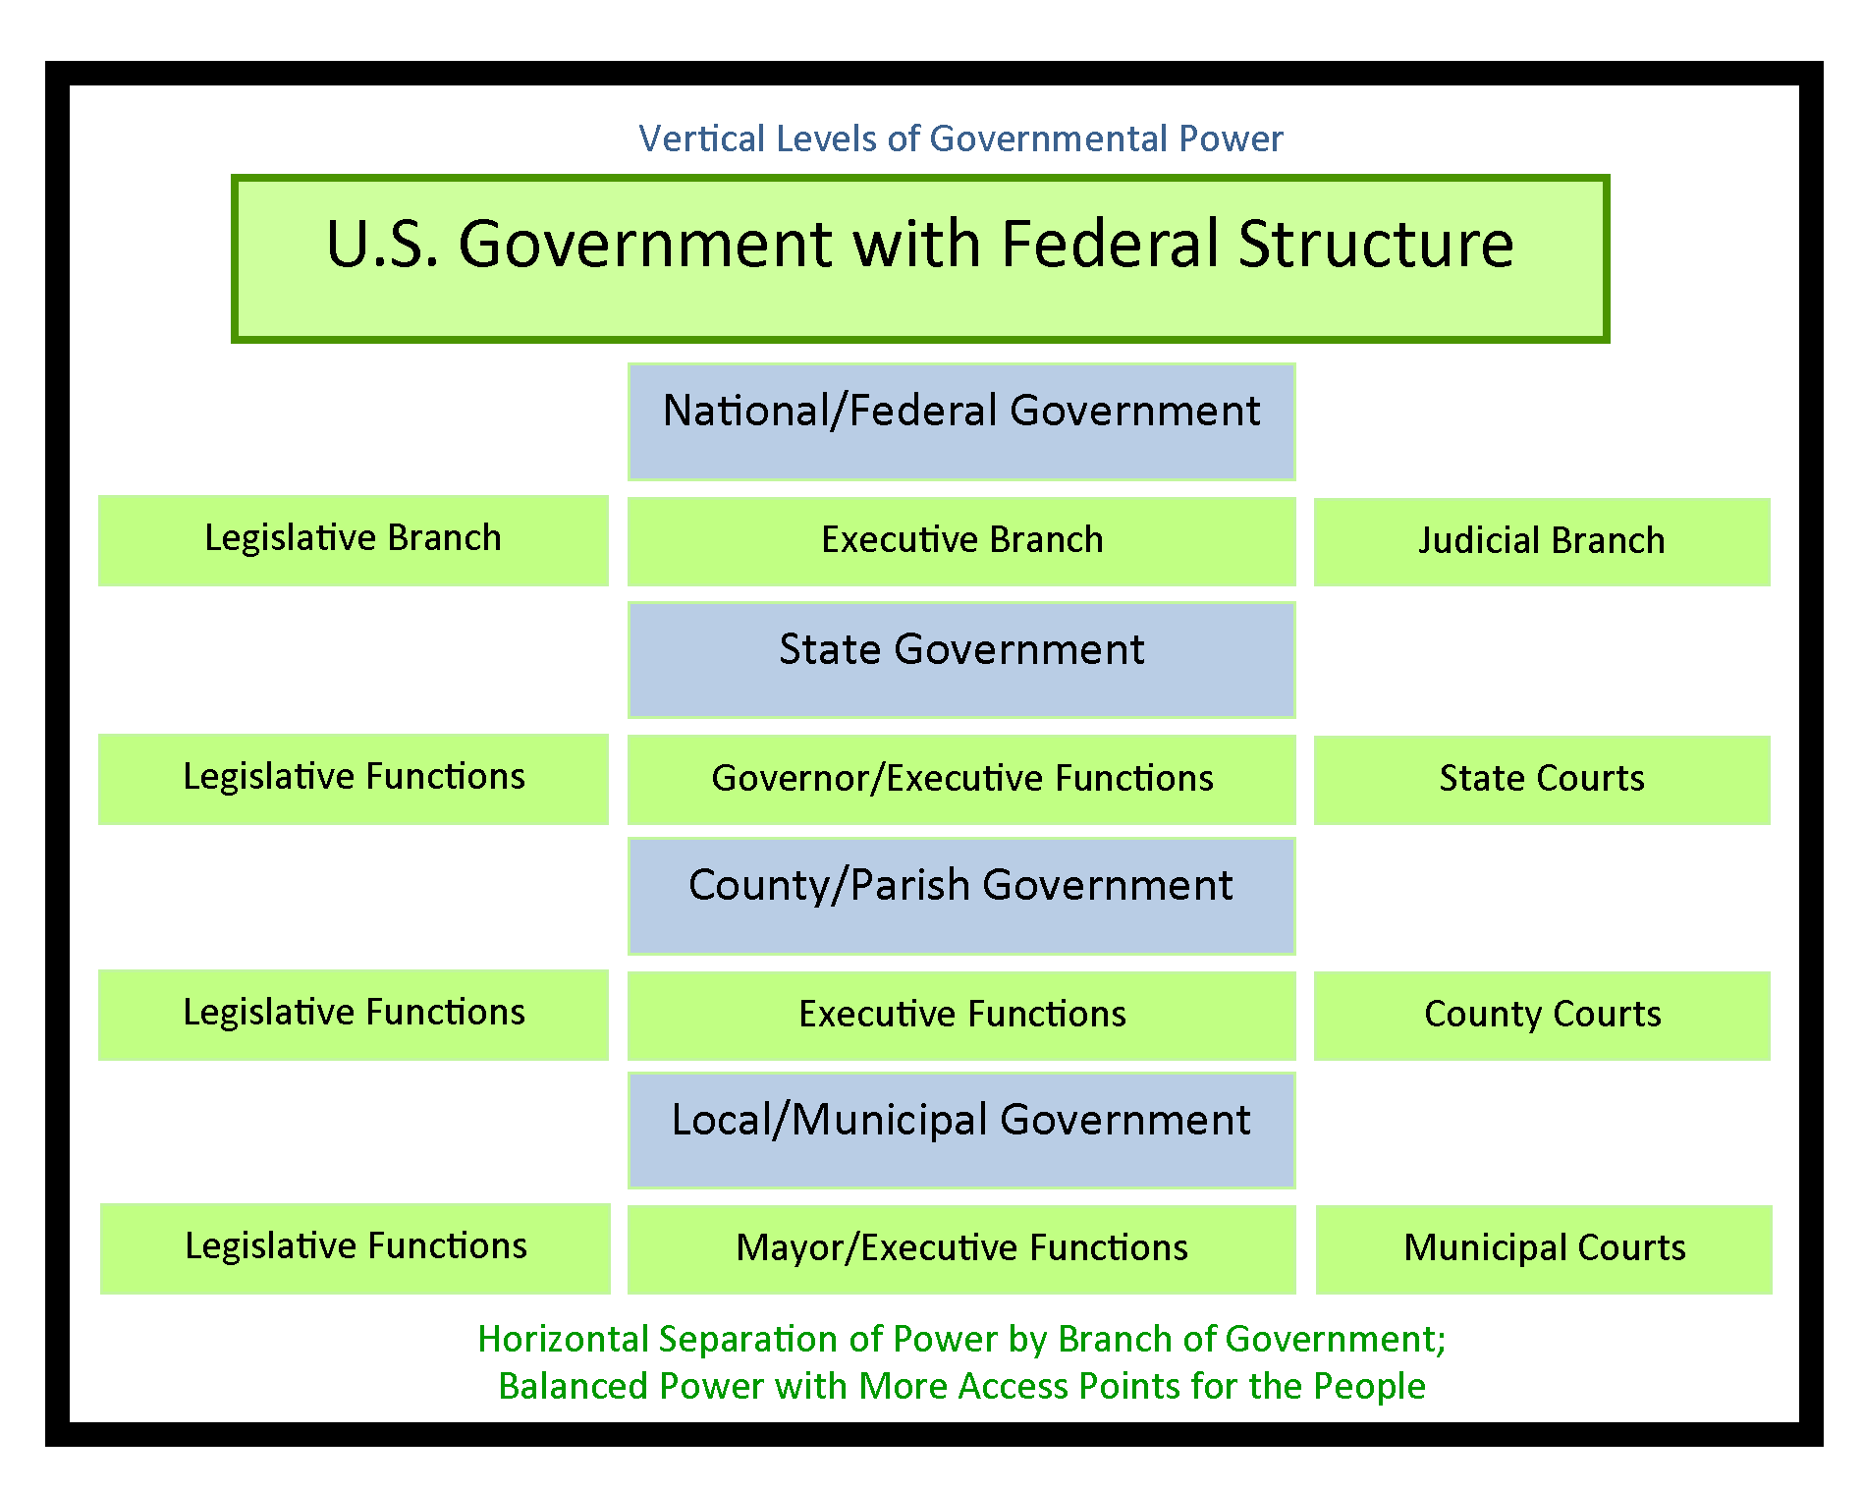
Does that sound like they wanted the Federal Government to be big & powerful? Actually, it is designed to do the opposite!
It means the powers of the Federal Government are FEW and DEFINED. Their powers are very limited, and they are named or listed in the Constitution. The Constitution says that any power NOT LISTED is a power of the States or the people. They listed the 20 powers Congress can pass laws about, and you will find them in Article 1 Section 8 and Article 2 Section 2 &3 and Article 3. Section 2.
It also has multiple levels of governments by having counties and cities that also have their own governments. This is designed to be sure one person or small group of people don’t have too much power and use it to impose tyranny.
Another benefit to Federalism is that each state has all the powers of the government (except the 20 listed in Article I Section 8) and they are able to experiment in their states & try their own ideas to see how they work. Also, it increases accountability of the local leaders to the citizens.⁶

Speaking of Separation of Powers ~ do you know where in the Constitution is the Separation of Church and State?
Regardless of what you have heard, there is no such thing! There isn’t anything like that in the Constitution, in fact, the Constitution Amendment 1 states “Congress shall make no law respecting an establishment of religion, or prohibiting the free exercise thereof…”
The phrase “separation of church and state” is nothing more than a simple comment made in a letter from Thomas Jefferson to the Banbury Church to ensure the members that there would not be a national religion. His statement was to assure them there would be a separation so the government could not control religion. Here is Jefferson’s letter. https://www.loc.gov/loc/lcib/9806/danpre.html
If a law conflicts with the Constitution, which one supersedes?
Neither Congress nor any state may make laws in conflict with the Constitution.
Each state also has its own constitution to govern their state.
Before the US Constitution was created, no other nations had a written constitution. Now, every nation in the world except 5 created a constitution using ours as a template. (England, New Zealand, Saudi Arabia, Canada, Israel)

The Articles of the U.S. Constitution
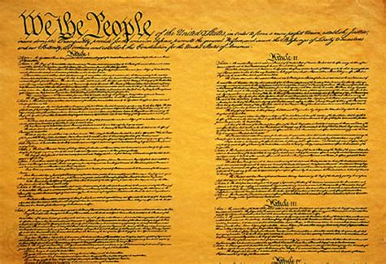
How many articles are there in the Constitution?
The Constitution is divided into seven articles; each article covers a specific responsibility and power. If you want to have some fun, ask someone who is running for office, (and about to take an oath to uphold the constitution), how they feel about the 8th article and see what they say. Then you will know if they will be able to uphold their oath or not.
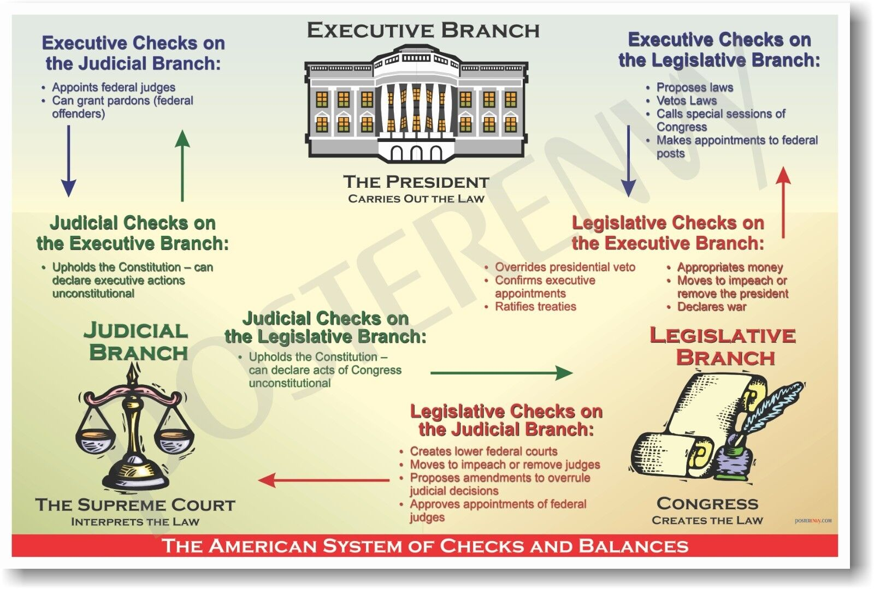
Why did the Founders want the powers of the Federal government separated & how did they do it?
The founders lived under the tyranny of their King where one person had all the power.
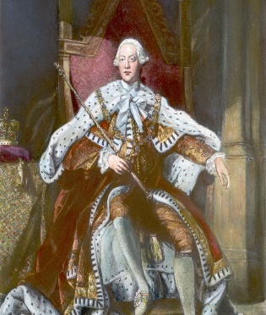
They sought to create a system that would limit the government’s power and protect the individual rights of the people.
They separated the power of the government by dividing power at the National level with the 3 branches and with Federalism.
Instead of allowing a single person, (like a king) a small group of people, (like an aristocracy or oligarchy) or the whole people (a democracy), they created a Republic.

The principle of “separation of powers” was implemented in dividing the federal government into 3 branches, each having very specific and different powers.
The Legislative Branch is the only one with the power to make laws.
The Executive is the only one with power to enforce laws passed by the Legislative branch.
The Judicial Branch’s only power is to interpret the law and determine if it is constitutional. They must apply it to an actual individual case. Once the Supreme Court interprets a law, The lower courts; the district courts, must apply the Supreme Court’s interpretation to that particular case.
What are the 2 main ways the Constitution separates powers?
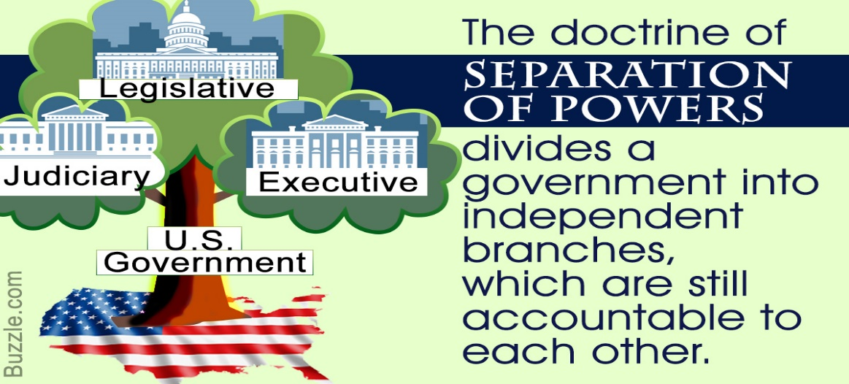
They divided the Federal government power into 3 separate branches.
Through Federalism - they specifically listed the few and defined powers of the Federal government and stated all other powers were the states and the people.
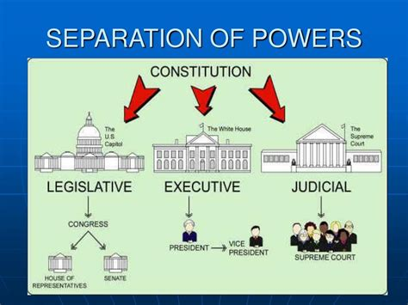

What are some examples of how the Founders separated the powers of the government besides the branches and with Federalism?

Divide the Legislative branch, Congress into 2 branches, the House of Representatives and the Senate.
Article 1 section 8 lists the specific powers of Congress and states they cannot pass laws that are not listed.
Article 2 states the few powers of the President and Vice
All bills regarding taxes has to start in the House of Representatives, (because they represent the people.)
Only the House has the power to file impeachment charges. If there is a majority vote in the House, the charges go to the Senate.
The Senate is the only one with power to hold an impeachment trial to remove the President, or any other elected Federal officer from office.

What are the “Checks and Balances” of the Constitution?
The Founders wanted each branch to be able to check and balance the powers of each other.
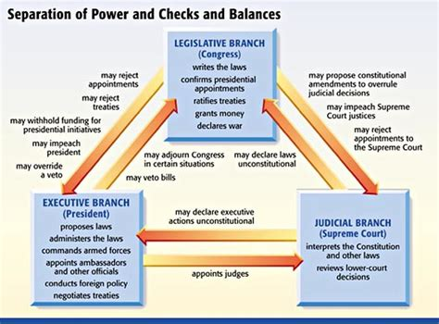
Only the Legislative branch, Congress can declare war, even though the Pres makes treaties and is the Commander in Chief.
The President can veto a bill passed by the legislative branch.
The Legislative branch can override the veto with 2/3 votes.
The President can pick executive officers and enter treaties but they have to be approved by the Senate so they can check the President.
The President chooses Supreme Court judges but the Senate has to approve them, giving them power to check the Executive branch and the Judicial branch.
The impeachment process gives Congress check & balance power over the other 2 branches.
The judges are appointed, not elected so they never feel the pressure of the voters.
Congress can impeach a judge for bad behavior so they can root out corruption and abuse of power in the other branches.
Congress has the power of the purse and can defund both of the other branches if they abuse their power.
The Judicial branch can declare laws or presidential actions unconstitutional.

Article I: Legislative Branch
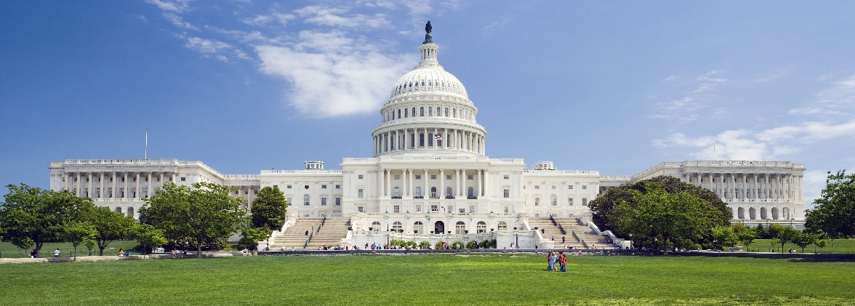
What is Article I about?
The legislative branch is known as Congress and is made up of the House of Representatives and the Senate.
This branch makes laws but only regarding 20 specific powers granted to them. They are not to make laws regarding anything outside those 20 powers as listed in Article 1, section 8, clauses 1-18.
Congress is both the House of Representatives and the Senate.
The House of Representatives
The House have 435 Representatives.
What is the job of Representatives and what are the qualifications?

Members of the House are to represent the people of their states. They are elected by the people to represent them.
A person must be 25 years old to serve in the House & been a citizen for at least 7 years & live in the state they run to represent.
The term of office for members of the House is two years because the Founding Fathers wanted these representatives to answer to the people they represent frequently. After two years, the people have the power to elect new leaders if they are dissatisfied.
Which is the only body with power to impeach?
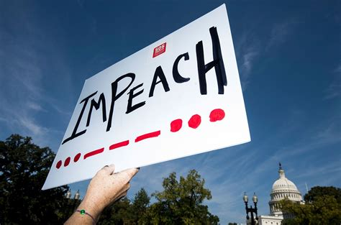

Only the House has the power to impeach a president.
The United States has 435 representatives. The number of representatives from each state is determined by population and can change depending on the population of the state.
States with higher populations have more representatives.
If one state gains a representative, another state loses one.
Fun facts: Seven states have only one representative: (Alaska, Delaware, Montana, North Dakota, South Dakota, Vermont, and Wyoming).
California has the highest number of representatives (52), down from 53 last year. This is the first time in California’s history they have lost a seat.
What if both the Pres and the Vice Pres were killed or died?
The Speaker of the House presides over the House. He or she is the next in line behind the vice president to the succession of the presidency.
Members of the House vote to determine the Speaker of the House. No one can be sworn in until the speaker is elected.
Which branch of government has the power to tax?
All bills dealing with taxes must originate in the House because taxation affects the people directly.
Why did the Founders decide to separate from England?
Taxation without representation was the 17th of the 27 grievances the colonists had against Great Britain. That means there were 16 reasons even more pressing that they were upset about. The king took their governors away and replaced them with his own. He took many of their unalienable rights as stated in the Declaration and didn’t allow them to govern themselves.
The 3/5ths clause

Artile 1. Section 2. clause 3. is where the 3/5th clause is. 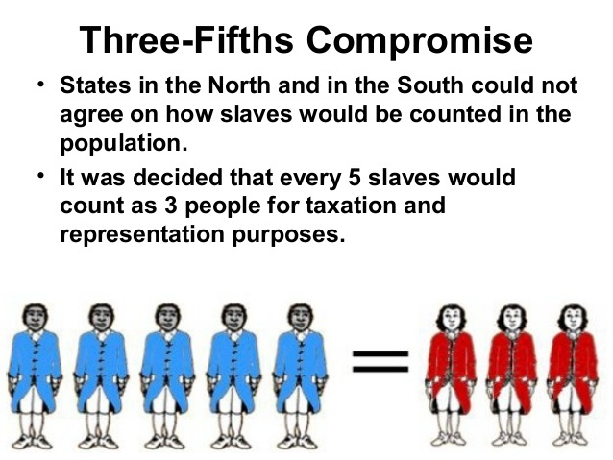

Why does the Constitution say slaves are counted as 3/5 of the population? Does that mean that the founders or even some founders perceived slaves or blacks as being valued at 3/5 of a person?
The number of Representatives is determined by population. The slave states wanted the entire slave population to count, giving them more Representatives; more votes in Congress. The anti-slave states did not want to increase the slave states power so they did not want to count the slaves in the population, which would give them more power.
Counting the whole number of slaves benefited the Southern states and reinforced the institution of slavery. Minimizing the percentage of the slave population reduced the population thus reducing the political power of slaveholding states.
In 1787, the founders were attempting to form a union and preserve the United States. This imperfect compromise allowed for the United States to be preserved.
How would you have voted if you were a delegate?

The Senate
The United States has 100 senators.
Why does each state have the same amount of Senators regardless of size? Each state has two senators, regardless of population because the Senators job was to protect each state from the federal government. The House were to represent the people by population and the Senate to represent each State so the size was irrelevant. This is how they got the small states and the big states to come together. They all got something they wanted but not everything they wanted.
Washington, DC does not have any senators because it is a city not a state as stated in the Constitution. Article 1 section 8 clause 17 states the federal government can only own 20 miles square, for the seat of the Government.
The term of office for senators is six years, the man or woman must be at least 30 yrs old & be a citizen for at least 9 yrs & live in the state they run to represent.
The vice president is also the president of the Senate. He or she votes only if there is a tie.
A Senator’s responsibility is to act as a sentinel to “protect his or her state
from the federal government and make sure the federal government does not take away the powers of the states. They were not originally intended to represent the people as that is the job of the Representatives.
A law must be passed by both houses to become law.
Only the Senate has the power to try a president for impeachment.
When is the only time the Senate acts as a judge?
The only time anyone acts as a judge,who is not a judge, is during an impeachment. Senators only function as judges during a presidential impeachment trial.
A presidential impeachment is an official hearing to investigate possible wrongdoing by the president. The Senate acts as judges to determine if there is enough evidence to convict and remove the official from office.
If a president is convicted by 2/3 of the members of the Senate present at an impeachment, he or she is removed from office and prohibited from future service. They may also be tried by a civil or criminal court & receive additional penalties if they are found guilty of a crime.
Article 1 Section 7
All bills regarding taxation must originate in the House.
Article 1 Section 8
The General Welfare clause & Common Defense clause state that the federal government can only legislate regarding the enumerated or listed powers -
James Madison “ The powers delegated to the federal government are FEW and DEFINED.”
Where are the 20 enumerated powers of Congress found?
Article 1 Section 8 lists the Enumerated 20 powers of Congress:
Tax and spend Pay the debts of the US
Power to borrow Regulate commerce
Establish postal system Pass copyright & patent laws
Establish federal courts Punish crimes on the high sea
Declare war Raise & finance armed forces
Establish rules to become a citizen Coin & regulate money
Standardize weights & measures Punish counterfeiting
Establish bankruptcy laws Call up militias
Administer the seat of the government Administer federal land
Congress is responsible for raising and supporting the Army and the Navy.
Pass laws to implement the above powers of Congress

Which is the only body of government that has the power to declare war & why?
Congress is the only body of government that may declare war against another nation because they are a large body and their children would be the ones to go to war.
No state may declare war or enter into a treaty with another nation. The power to declare war and sign treaties is given to the federal government.
If Congress cannot meet, the executive branch has power to follow through on the federal government’s guarantee to protect each state against invasion.
The federal government can only own 10 miles sq of the seat of the government, (now Washington DC) and Forts, Magazines, Arsenals, dockyards, & needful buildings.
What does Article 1 Section 8 clause 18 do?
That is where the Necessary & Proper clause states that Congress also has power to pass laws that are necessary & proper to fulfill or carry out the 20 enumerated powers that were just listed.
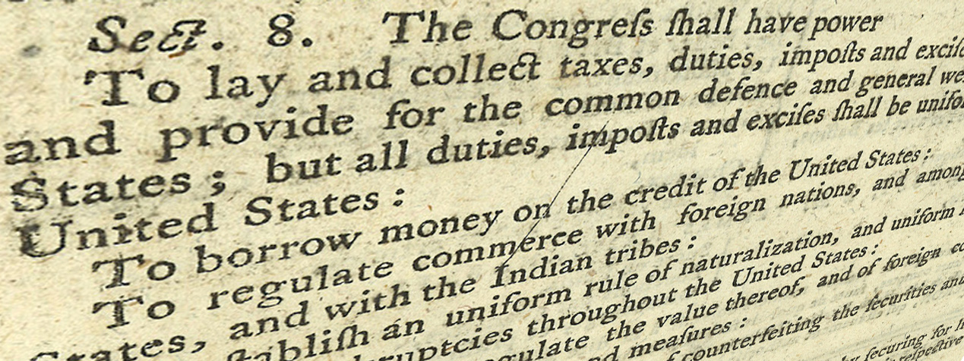
General Welfare Clause Powers
2) borrow Money
3) regulate commerce
4) establish rules of naturalization
5) coin money
6) punish counterfeiting
7) establish post offices & post roads
8) protect exclusive rights & copyrights patents
9) constitute inferior courts
17) control DC & federal lands approved by states
Common Defense Clause Powers
10) define & punish piracies & felonies
11) declare war
12) raise & support armies
13) provide & maintain a navy
14) make rules for land & naval forces
15) call forth the militia to execute laws, suppress
insurrections & repel invasions
16) organize, arm and discipline militia
Clause 18 states that all the laws which shall be necessary & proper for implementing the prior listed powers.
What does Article 1 Section 9 list?
Article 1 Section 9 lists the powers that Congress is forbidden.
*They had to end the importation of slaves by 1808.
The Founders attempted to end slavery by limiting importation of slaves in the year 1808 & by taxing slavery.
What is Habeas Corpus?
Habeas Corpus cannot be suspended or removed. Habeas Corpus is a legal recourse that allows a person who believes they are being held without a valid cause to go before a judge to determine if the detention is lawful. The Constitution protects this right.
What is a Bill of Attainder?
Congress cannot pass a Bill of Attainder or ex post facto law.
Bill of attainder is a law that singles out an individual or group for punishment without a trial. The king would accuse someone he didn’t like of a crime and then seize their property.
What is Ex Post Facto?
Ex post facto is a law that makes illegal an act that was legal when committed or makes the act retroactively illegal. Congress is forbidden to pass an ex Post Facto.
States do not have the power to do any of the 20 powers that are given to Congress, without their consent.
In the original constitution, Congress could not tax people directly, they could only tax the states. The 16th Amendment changed that, giving Congress power to tax people directly on their incomes.
Article 1 Section 10 limits the powers of the states.
Congress must meet at least once every year.

Article II: Executive Branch
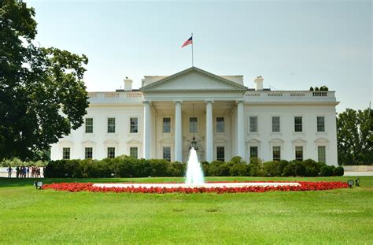

What is Article II about?

Article II is the Executive branch of the U.S. government
Who is in the Executive branch?
The executive branch consists of the president, vice president and his or her cabinet. Their responsibility is to enforce the laws.

What is the power of the Executive Branch?
Their responsibility is to enforce the laws.

How long does the Pres and V Pres serve in a term?
The term of office for the president is four years.

In the original Constitution, how was the president elected?
The president is elected by electors.

How long is the term of office for the President and V President?
The term of office for the president is four years.
How was the President elected in the original Constitution?
The Founders created the Electoral College to choose a president.
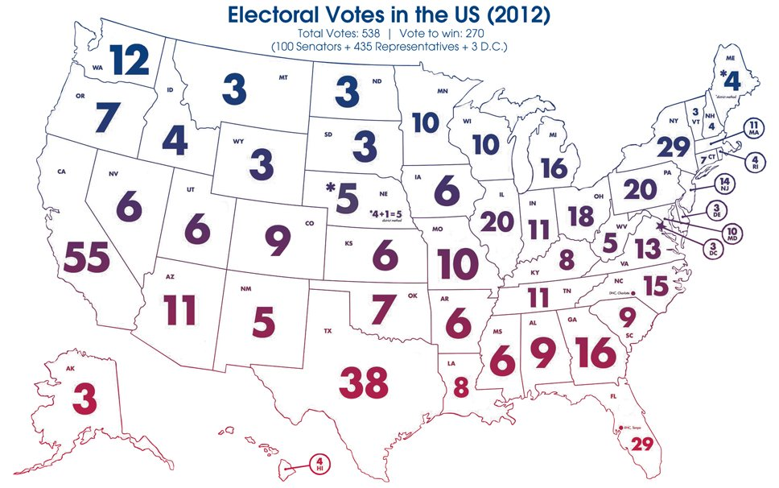
Why did the Founders think the Electoral College was a superior way to elect the President over the popular vote?
The founders did not want ANYONE to run to be the president. They did not want anyone to seek this office. They wanted electors who represented the people to submit names of the best people to choose from. The original constitution did not include the popular vote to elect the President.
In fact, did you know that originally, no one could RUN to be the president?!
Each state elects delegates, electors, to go to the Electoral College. The number of electors is the total of all Representatives and Senators combined. Originally, the electors submitted, to the US Congress, the names of 2 people they thought had good character and would be an honorable president.
Then the Senate president (Vice President) counts all of the Electors votes and the person with the most votes becomes the president. This is a summary of the process, and it has been changed many times over the years.
The president is elected by electors, not the people.
Each state elects delegates go to the Electoral College
Can a candidate win the popular vote of all individuals in the United States but still lose the election based on the electoral vote?
Yes, The number of electoral votes always determines who the president will be, regardless of the popular vote. They did not want high population cities or states to take control of the presidency.
Did you know that if we used the popular vote without the Electoral College, the 10 most populated states could determine the outcome of the Presidential election?
Because more than half of the population of the entire United States live in 10 states, they could always choose the president. The Founders did not want to have a small group or minority of people take over the elections, they wanted to have representatives from all across the nation choose the President.
What are the reasons the Founders created the Electoral College instead of a democratic popular election?
The president was to represent the nation and national interests.
They did not want someone to seek the office of president & they were confident the electors would choose an honorable, qualified person.
The founders were concerned a tyrant would be able to manipulate the public opinion and get into power. They felt that when people of honor submitted names of other people of honor that would be a safety shield against tyrannical leaders.
The founders also believed that because the Electoral College was a group that met only once they would not be able to be manipulated over time.
What are the qualifications to run for President?
The president must be a natural-born citizen.
Why was that important to the Founders?
The Founding Fathers felt someone born a citizen would be more likely to have the interests of the United States at heart. They wanted to protect the nation from foreign influences or from anyone who would have other allegiances.
One must be at least 35 years old to serve as president of the United States, and have lived in America for 14 consecutive years.
Who is the commander in Chief of the U.S. Army and Navy?
The president is the commander in Chief of the military.
How long is the term of office for a president?
It is 4 yrs and originally there was no term limit, but the 22nd Amendment changed it to up to 2 terms.
If the president dies, who becomes the president?
The vice president may serve for the remainder of the president’s term in office and may still be elected to serve up to two additional terms, if the time remaining in the original president’s term was less than two years.
Can the President, Vice President or civil Officers ever be removed from office?
They can be removed by impeachment & conviction of Treason, Bribery or other high crimes.

Remember, the House charges them with impeachment, then the Senate holds the trial and decides if they should be removed from office. It is the only time the Senate acts as judge.

Article III: Judicial branch
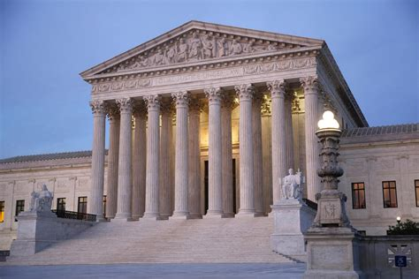
What is Article III about?
Article III is the judicial branch & made up of judges appointed to the Supreme Court. 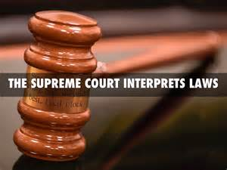
Who appoints the Judges?
The president chooses a candidate to be a judge and then the Senate has a hearing to decide if they will give consent. A Supreme Court judge is appointed by the President and then approved by the Senate.
What does the Supreme Court do?
Their job is to interpret the law and make sure it is aligned with the Constitution. They may declare acts of the executive or legislative branches to be unconstitutional.
How long does the Constitution say is the term of office for a Supreme Court judge?
The constitution states that a judge holds his or her position during good behavior. That may be for life, depending on the judges behavior.
When is the only time a citizen does NOT have a right to a trial by jury?
Every citizen has a right to a trial by jury, except in cases of impeachment. Trial by jury is an important check on the federal government. It protects citizens from tyranny by the federal government by placing power in the hands of the people instead of government officials.
Requirements to run for each office:

Representative Senator Pres & V Pres
Age 25 yrs old 30 yrs old 35 yrs old
Term 2 yrs 6 yrs 4 yrs
Live in US 7 yrs 9 yrs 14 yrs & born in the USA

ARTICLES 4-7
Article IV: State and Federal duties
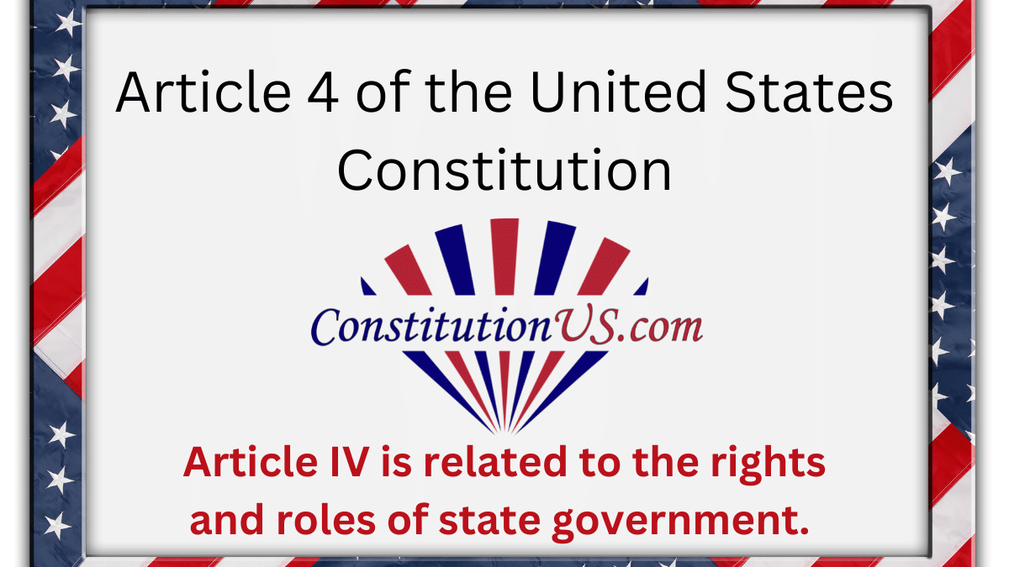

What is Article IV about?
Article IV explains the duties of cooperation of the states with each other and
with the federal government.
It defines states powers. States do NOT have rights. Rights are endowed by
the Creator to individual people.
States and businesses are created by man and given powers, not rights.
It ensures cooperation between the states when sharing public records,
extraditing criminals and honoring the laws of the other states.
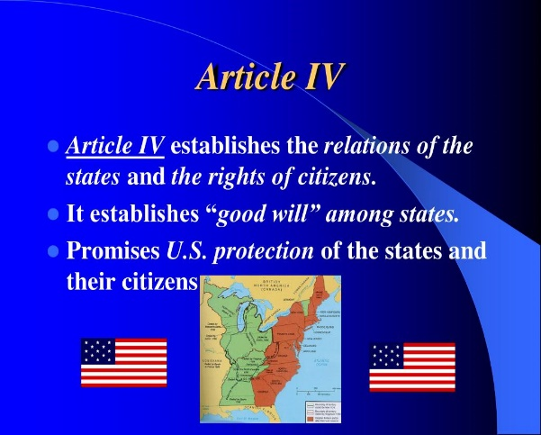
What is the only thing the Constitution requires the states to do?
It requires each state to provide a Republican Form of Government.
It also confirms it is the federal governments responsibility to protect each
state against invasion.
New states may receive admission into the union with approval from Congress
No state may be created inside another state.
Two states may not merge together to make one state or divide itself without Federal approval and the Federal government can’t divide a state or join states together without states approval.

Article V: The Amendment Process
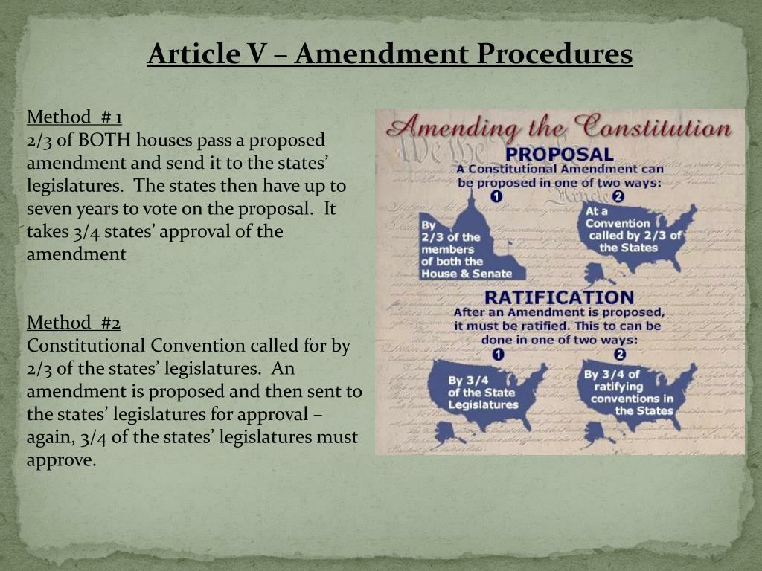
What is Article V about?
It explains the right of the people to change the Constitution by using the
amendment process and lays out 2 ways it can happen.
How many ways are there to make changes to the Constitution?
There are 2 ways to change the Constitution. The 1st method, (the one used
for every amendment passed so far) is Congress proposes an amendment &amp;
if 2/3 of each the House and the Senate vote for it, they present it to the
states. Then each state decides whether or not they want to ratify it and if 3/4
of all the states vote for it, it becomes an amendment and is added to the
Constitution.
This makes it so even a minority of states can stop an amendment from being
passed.
The 2nd way is if all the state legislatures apply to Congress to call a
convention for proposing amendments. If an amendment is approved, it has to
be sent to the states for ratification and must be passed by ¾ of the states to
be added to the Constitution.
Although this method has never been used, several states have passed
legislation to propose amendments.

There are 27 AMENDMENTS in all.
The first 10 are the BILL OF RIGHTS
Important point! These amendments, The Bill of Rights, DID NOT CHANGE the Constitution, but made clear the principles already in it.
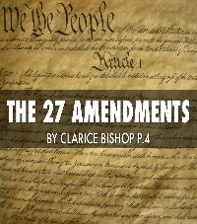
How many times have we changed the Constitution?
Yes, we have made changes to our Constitution 17 times.

Article VI: The U.S. Constitution is the supreme law of the land.
What is Article VI about?
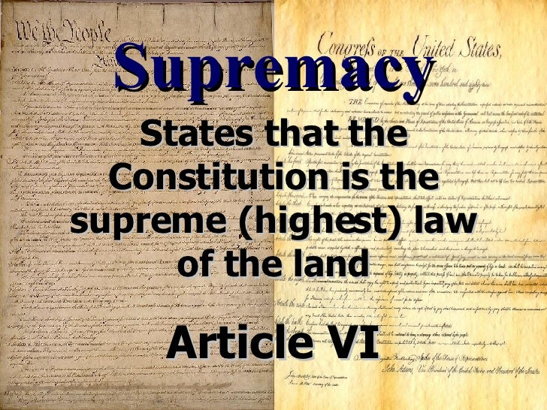

Article VI states the Constitution is the supreme law of the land. That means
any laws Congress passes or anything the President or a judge does is invalid
if it does not align with the Constitution. The Constitution is the supreme law.
Remember, the Constitution protects the powers of the states and the people.

Article VI also states that any debts already incurred before the ratification of the
Constitution are valid & honored by the U.S.
The Revolutionary War was expensive and brought a great deal of debt. Did the
Founders think that because there was so much debt, since we were starting a new country anyway, should we not pay our debts?
The Founders insisted we pay our debts for the following reasons:
● Debts must be paid in order to have public Morality.
● Debt always ends in having to tax the people which puts them into
bondage.
● Debt has a very negative effect on national prosperity
● Once debt is incurred it is easy to continue to take on more debt and
harder to preserve the limits imposed by a free constitution.
Article VI also prevents states from making laws that conflict with the Constitution
stating they would be invalid.
All treaties made must be done in pursuance of (in alignment with) the
Constitution and under the authority of the US.
Judges in every state shall be bound to the Constitution.
All federal and state Senators, Representatives, Legislators, executive officers
and judges must take an oath to uphold the Constitution, not their own conscience.
There cannot be a religious test required as a qualification to hold any office..

Article VII: Ratification Process
. 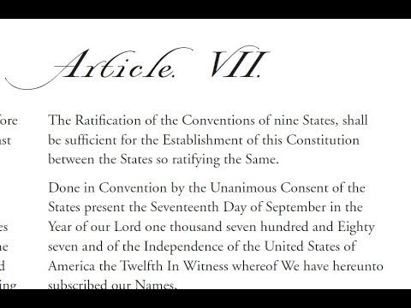
Article VII is about the requirements to ratify the Constitution. The ratification process is
the official approval and acceptance of the Constitution.

It states the Constitution may be ratified when 9 of the 13 colonies in the
Constitutional Convention voted to approve it, but they really wanted ever
state to accept and ratify.
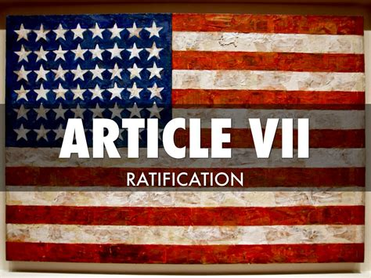
The federal government uses the same process to approve a state joining the
union.
The Constitution was ratified by the necessary 9 states on Sept 17, 1787 but
was ratified by all 13 states when Rhode Island finally signed on in May 1790.
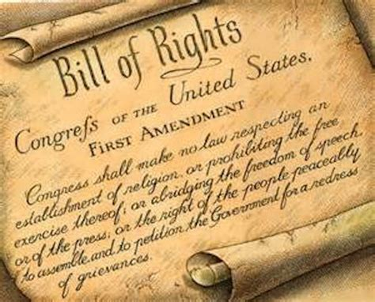
The Bill of Rights (the 1st 10 amendments) was ratified in 1791.
The Bill of Rights is NOT a list the rights of the people. The founders knew
they could never list all of our rights and did not want to risk leaving anything
off and not have it protected.
It IS a list of the specific rights the federal government CANNOT restrict
nor pass laws to restrict. It guarantees protection from the federal
government of those specific rights and makes clear the limitations on the
federal government.

