**2025 The Bill of Rights & Amendments**

**Please note that the only Amendments that will have questions**

**are those with pictures.**

**What is the Bill of Rights? It is NOT a list of rights. The Bill of Rights does not make any changes to the Constitution, like the other amendments do. It tells the government what God given rights they cannot make any laws to limit these rights. The Bill of Rights says to the government, HANDS OFF THESE RIGHTS!**

**How many “Amendments” are in the Bill of Rights?** There are **10 in the Bill of Rights**, and **17 Amendments** that changed the Constitution. So, **27** altogether, but only **17 t**imes the Constitution was **changed**.

**What rights does Amendment 1 protect?**

It states Congress cannot make any laws restricting our rights to freedom of **religion, speech, press, redress or assemble.**This means that Congress **must protect our right to**:

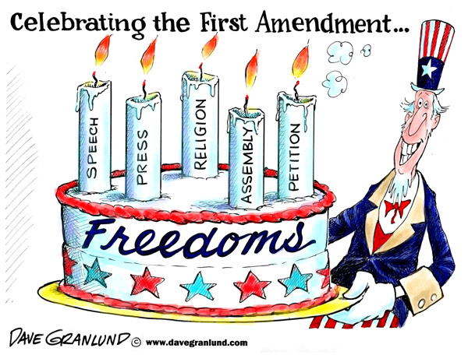

* Religion: exercise your religion & faith or conscience without prohibition.
* Speech: speak our minds & say what we want, even if others do not like it.
* Press: free press that can circulate news, even if it is unfavorable to those holding positions.
* Asembly: gather or meet in groups.
* Redress: petition the government to be heard & express concerns when they feel justice has not been served.

**Freedom of Religion** The Pilgrims and Puritans did not have religious liberty in England and suffered great persecution for their beliefs. The Founders believed that no one could be free without religious liberty and the right of conscience.

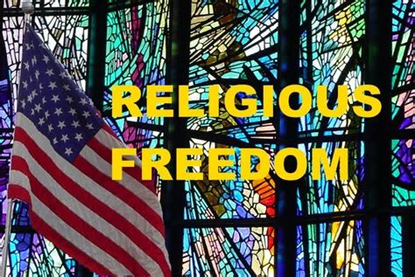

"The Religion then of every man must be left to the conviction and conscience of every man: and it is the right of every man to exercise it as these may dictate." —James Madison, 1785.

A coach was praying on the football field before a game. He did not force any of his players to join him but allowed those who asked if they could. Yes

The Governor wants to reduce crimes, so she does an executive order requiring everyone to go to any church they want? Is that constitutional? No

The Governor doesn’t want anyone to feel left out so she passes an executive order forbidding everyone from praying in public or going to church? No

**Freedom of Speech** The Founders were not allowed to speak against the king without suffering serious consequences.  They wanted to protect peoples’ right to speak openly about issues and concerns they had with the government and others. Does that mean that people have a right to use hate speech? What about saying things that make others feel bad or don’t like?

Why do we need protection of speech if you can only say things that others like? The point of free speech is to be able to discuss and debate every idea without fear of reprisal. You can speak as long as you do not violate someone else’s rights.

If you do not like what your governor, or your mayor, are doing can you express your dislike to them or can you share it with others? Yes

A coworker got mad at your boss and yelled at him and called him names in front of others. He fired your friend. Your friend said he was going to sue because he has freedom of speech! Does he have a case? No, because the rights in the Bill of Rights apply to the government, not to private business.

"Driven from every other corner of the earth, freedom of thought and the right of private judgment in matters of conscience direct their course to this happy country as their last asylum." —Samuel Adams, Speech on August 1, 1776.

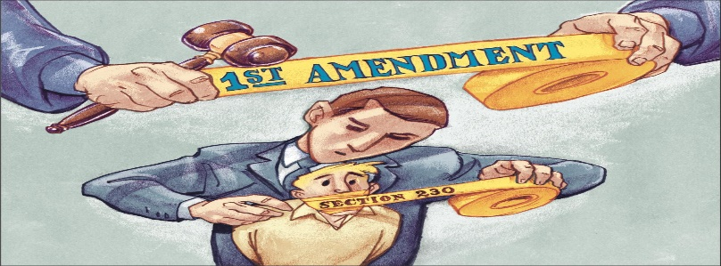

**Freedom of the Press**  This freedom allows people to publish their opinions and information without the government stopping them. This may be through any type of media including the newspaper, radio, TV, printed pamphlets, or online. This does not allow one to take the freedom of others by publishing or printing lies about people to damage their reputation (this is called defamation) or copying someone else’s work (copyright law).

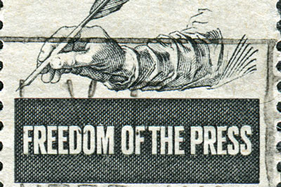

The editor of a public school newspaper recently approved an article that detailed the unhealthy food served in the school cafeteria, but the principal didn’t want to hurt the feelings of the cooks so he wouldn’t allow him to print it. Not ok.

You write an article (op ed) in your local town newspaper and expose how the city will not fund the repairs of the city swimming pool needed in order to open that 75% of residents used, but were going to fund over $250,000 for a new ice sheet that less than 3% of residents would use. The council members are very angry and upset & told the newspaper they would pull their business license and shut them down if they printed it. Gov cannot control or suppress the press, even if they do not like what they say.

"While we are contending for our own liberty, we should be very cautious not to violate the conscience of others, ever considering that God alone is the judge of the hearts of men, and to Him only in this case are they answerable." —George Washington, in a letter to Benedict Arnold. 

**Right to Assemble** This freedom gives people the right to gather in groups as long as they are peaceable. The government must allow people to gather on public property. This allows people to hold protests and rallies against the government calling for changes. In some cases, the government may get involved in order to protect the safety of the citizens. Permits may be required to hold large protests, but the requirements for the permits cannot be too difficult to meet and must be required for all organizations, not just some of them.

**"Conscience is the most sacred of all property." —James Madison, 1792.**

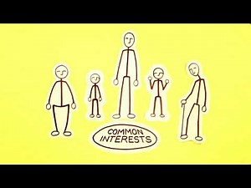

The government tells you that you cannot have a religious meeting at your home. No, you have a right to assemble as long as you are peaceable.

You gather your friends to meet at the Capitol to protest the bill to get rid of daylight savings time. You are peaceable but tell legislators you want to keep it & reset your clock every 6 months. Yes, you can meet and protest as long as you do not violate others rights or destroy anything.

**Right to Redress or Petition the Government**  The right to petition the government was important enough to the Founding Fathers to include in the First Amendment. They wanted a way for the people to officially bring issues to the government. This right allows individuals or special interest groups to lobby the government & sue the government if they feel they were wronged.

Heavyweight boxer Mahamad Ali was drafted into the Vietnam War but he refused to go because it was against his religious beliefs. He was convicted of draft evasion and sentenced to 5 yrs in prison. He sought redress and fought the decision in supreme court, and his conviction was overturned. Petitioning for redress does not always have the desired outcome but it always allows you to share your grievances.

**What rights does Amendment 2 protect?**

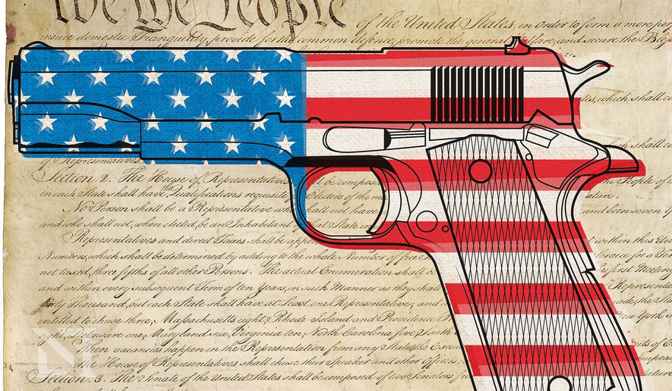

It states that it is essential to our liberty to have a well regulated Militia and forbids Congress from passing any laws that infringe on the rights of the people to keep and bear arms or guns.

CONTEXT: It was the citizens, farmers & merchants, not soldiers that had to defend themselves against their own government when the British soldiers marched from Boston Harbor to Lexington and Concord and opened fire against them known as “The shot heard around the world”.  They understood that freedom could only be held by the people if they had the power to defend themselves against all enemies including if necessary, their own government. They wanted to be sure the right of self-defense could never be taken from the people.

Jim goes to his friend, Luke’s house to hang out. He sees a gun safe with a couple guns in it. He wants to know why Luke has guns!? Luke explains he has a right to defend himself against an intruder & for self defense. He has also taken training and practices, so he knows how to be safe.

Sarah told her neighbor that she and her dad were going to take their guns target practicing on the weekend. Her neighbor got worried and called the police and they showed up at Sarah’s house. They told her dad they were going to take her guns to the station for a few days until the neighbor feels better. Is that legal? No, Sarah and her dad are law abiding citizens & have a right to own guns. They can only have them taken if they use them incorrectly or violate someone’s freedom.

**What rights does Amendment 3 protect?**

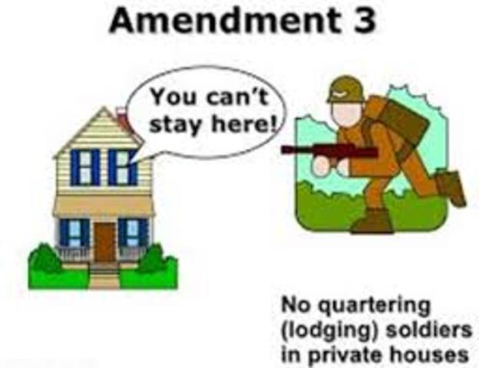It states No soldiers shall be quartered, or housed in your home without your permission. During the war Soldiers would move in and take over the Colonists homes without the permission of the homeowners because they were under the control of the King.

If the National guard comes to Utah to help us with an earthquake and knock on your door and tell you they are going to move in and take over your house. Do you have to let them? No, but you can if you want.

**What rights does Amendment 4 protect?**

People have the right to privacy in their -

* homes,
* papers,
* effects (all their stuff) and their
* persons - the government can't search you, your body, or your stuff without your consent or a search warrant.

Luke was driving home one night after his baseball game. A police officer pulled him over and told him he wanted to look inside his trunk. Luke asked the officer if he had a search warrant, and he told him he did not. Luke did not allow the officer to search his trunk. Was he right? Yes

Susan was walking through the mall when an officer stopped her and asked her to search her purse. She politely asks him if he has a reason and a search warrant. He said he did not, so she did not allow him. Did she have a right to do that? Yes.

**What rights does Amendment 5 protect?**

Article V is about due process and includes 5 important protections in criminal cases.

1. You are entitled to a jury trial
2. No double jeopardy, you can’t be tried twice for the same crime
3. You don't have to testify against yourself.
4. You get due process, the government can't take your life, liberty or property without having due process.
5. You can’t have your private property taken for public use without compensation.

Everyone gets a trial regardless of guilt or innocence so that both sides can bring all the evidence forth.

Once charged & tried for a crime, the government can’t come back and charge you again & again with the same crime just to punish you because they don’t like you & bleed you financially a the king had done.

No one must testify against themselves. This protects us from giving evidence that would damage us in court. This stems from the Puritans who were often beaten until they admitted their beliefs or tortured for their faith. Pleading the 5th does not mean that a person is guilty, as a witness may have a reasonable fear of prosecution and yet be innocent of any wrongdoing.

Everyone gets all the due process listed here and included in Amendments 6, 7, 8 before you can lose your life, your liberty or property. No other country has so many protections in place.

If the government needs to take your property for the good of everyone, they must pay you for it.

John attended a protest where he broke windows, lit a car on fire and a riot broke out. John was arrested and charged with several crimes. Since there were police there and saw John, does the judge need to hold a trial or can he go ahead and convict & sentence him? Everyone, guilty or innocent is entitled to a speedy jury trial so all evidence on both sides can be presented.

You are shopping with your brother when he shoplifts & he gets caught so you both get arrested. You do not have any stolen items on you. You decide to Plead the 5th as you do not want to incriminate your brother. That is your right.

Jane was charged with and tried for murder. The jury could not agree on her guilt, decided the evidence was not conclusive and found her NOT guilty. She then wrote a book about how she had indeed committed the murder. Could she be tried again for the same murder? NO. No double jeopardy.

Due to so much traffic, the government decided to put a freeway in from Scipio to Green River. Unfortunately, it will go right through your friends property. Can the government declare eminent domain and take their property for the freeway even if your friend does not want to or can they stop the freeway from going in by refusing to sell? Yes, your friend has to sell to the government only for public good, but they are supposed to pay current market value for it.

**What rights does Amendment 6 protect?**

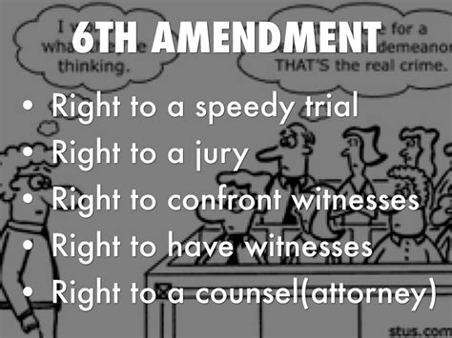

It gives protection to citizens in **criminal cases**. There are 6 due process protections in Amendment 6!

**We are all entitled to:**

1. **a speedy trial.** The Founders knew we could not have freedom if we had to **wait in jail for years** for a trial as happened under the rule of King George.

**2. to have a jury of our peers.** They knew that if trials were decided solely by judges, the judges would, more often than not, side with the government. This would, in turn, give the government too much power. They knew trial by jury would ensure a better chance for a fair trial.

**3.** **a right to know what crime we are being accused of.** No one could defend themselves if they didn’t know what crime they were charged with and who was accusing them.

1. **to confront & question our accuser.**
2. **to call (subpoena) witnesses to appear and speak in our favor.** It is vital we all have the right to have witnesses testify about what they know.
3. **a lawyer to defend us.** Most of us are not legal experts so we need an attorney to help & represent us in court.

Caleb had several parking tickets he did not pay so the judge ruled that his trial would start in 4 years. Nope, it must be speedy, so asap.

Some of the Colonists that spoke out against King George were taken by the king to England to be tried by a judge. They had no friends there & no one to help them. Do you want a judge to decide what happens to you if you are charged with a crime or do you want people that think like you and understand you to decide if you are innocent or guilty?

Daniel was riding the subway when a man on drugs starting hurting passengers around him and threatening to kill them. Daniel restrained him with other passengers until the police arrived. Unfortunately, the man on drugs died on his way to the hospital. Daniel was charged with manslaughter & a jury of his peers, people like him, listened to all the evidence and ruled he was not guilty. Would you want a judge or jury to decide what happens to you? This is a rare & sacred protection for us.

John had a knock on his door and the police told him they were arresting him. He asked what he was being accused of, but the police just told him it was for a crime but would not tell him what crime. Can you imagine being charged with a crime and having no idea what it is? How could you defend yourself? You have a right to know what you are accused of.

Lori was charged & arrested for stealing a bike. She claims she did not do it & doesn’t know who is accusing her but has an idea it might be a neighbor that is mad at her. The accuser does not want to be named, but the police tell her she must be known if she wants to press charges. Do you think you would want someone to accuse you of a crime and never come forth with their identity? This protects the innocent and is fair to the guilty

Daniel was charged with a serious crime and was arrested. When he got to trial, he had the witnesses go to his trial and testify on his behalf. The jury found him not guilty. Would you want people who have evidence in your favor be able to share it with the jury? You cannot have justice without it!

George got arrested for hitting a police officer. He lost his job and is homeless and has no money to pay for an attorney. He needs to have legal help to defend himself. Is he entitled to an attorney even if he can’t pay for one? Yes, everyone gets an attorney. If a person can’t afford it, the taxpayers will provide one so he can be represented and have a fair trial.

**What rights does Amendment 7 protect?**

Protection of rights in **civil cases** and trial by jury.

The founders wanted to be sure everyone got a jury trial, even in civil cases. They knew that if trials were decided solely by judges, the judges would, more often than not, side with the government. This would, in turn, give the government too much power. They knew trial by jury would ensure a better chance for a fair trial.

Amanda got invited to the school dance and didn’t want to spend $200 for a new dress. Her friend Susan let her borrow the one she wore to the last dance. When Amanda took the dress back to Susan, Susan noticed a stain on the dress. Amanda said it was already there, Susan said it was not. Amanda refused to replace the dress so Susan sued her. Do they get to have a jury trial or will the judge decide? They have a right to a jury trial, even in a civil case.

**What rights does Amendment 8 protect?**

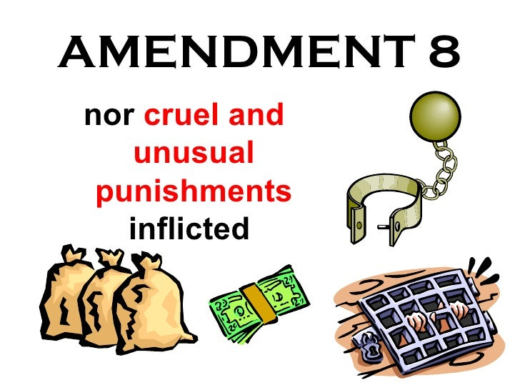Protection from excessive bail or fines, and any cruel or unusual punishment.

Walker was walking home from a football game one night & he was tired, so he decided to take a shortcut through a neighbor’s yard. The neighbor was upset to see a young man walking through their yard at night and called the police. They charged him with trespassing and Walker was found guilty and sentenced to 15 years to daily electrical shocks. Does that seem unusual or excessive for the crime? The punishment must fit the crime.

**What rights does Amendment 9 protect?**

Rights are retained by the people even if they are not mentioned, listed or referred to in the Constitution or the Bill of Rights.  
Just because a right is not mentioned in the Constitution or the Bill of Rights, does not mean the people do not have it, the rights are retained by the people regardless.

The federal government tells Utah’s state school board what standards they have to adopt to be aligned with other states. Utah state school board does not like the standards, so they refuse to adopt the standards. Does the state have the power to not adopt the standards? Although education is not listed in the Bill of Rights, it is not in a power the Federal government ( not listed in Article 1 section 8) so the state does not have to comply.

**What rights does Amendment 10 protect?**

All powers that are not specifically delegated to the federal government, or not specifically prohibited to the states, are the powers of the states and the people.

The Federal government tells the state they cannot build roads in our state. If it is NOT a power specifically listed as a Federal power, and it has not specifically forbidden the states to do it, the states & people have the power, not the Feds. Does the Federal government have the power to stop us from building roads? No, as it is not a federal power.

There are 27 amendments which means that the Constitution has been changed 17 times. No, not 27 times, because the Bill of Rights did not change the Constitution, it did not list the rights of the people. It clearly  forbids the federal government from passing laws restricting these rights

**Amendment 11** - Prohibits the federal courts from hearing certain lawsuits against states.

**Amendment 12** - Changed the Vice President from being elected by the second highest vote

**Amendment 13** - Ended slavery! Finally!

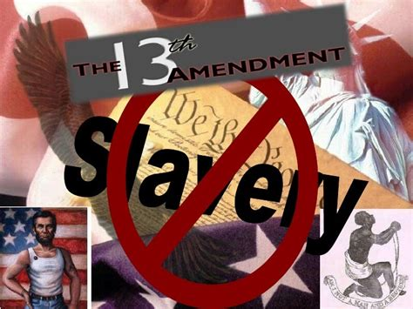

It was ratified in 1865 bans slavey (& involuntary servitude, except as punishment for a crime.)

**Amendment 14** - Protection of civil rights for all

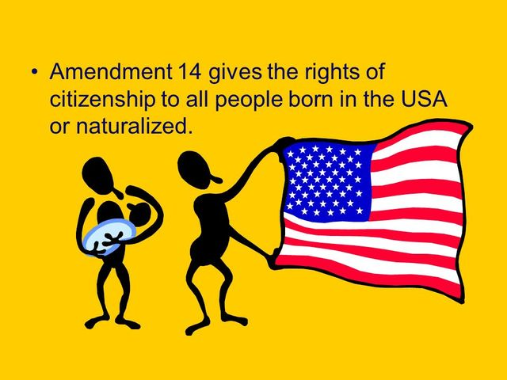

It defines American citizenship & declares no state may deny anyone equal protection under the law. It was enacted to ensure all states would provide equal protection to former slaves as some states were not.

**Amendment 15** - Forbids racial discrimination in voting.

It was passed to specifically address racially motivated rules and restrictions to impede Blacks voting. It states that the right of citizens to vote will not be denied based on race, color or previous conditions of servitude.

**Amendment 16** - Congress imposes income tax directly to citizens.

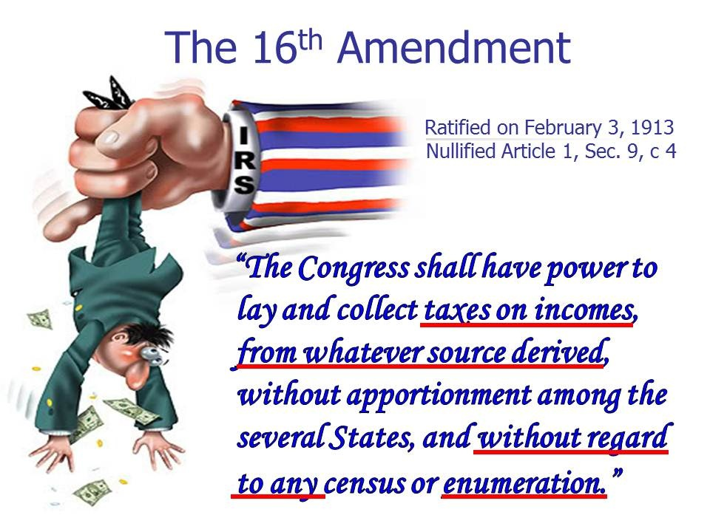

This amendment proves that really bad amendments can get passed! Prior to the 16th, the Federal government could not tax citizens directly, they could only tax the states. The states had far more power over spending prior to it. This amendment made it legal for the federal government to collect taxes on the income of citizens and corporations. The national debt started to really increase after it was passed.

**Amendment 17** - Changes the way Senators are elected from being elected by the state legislators to being elected by the citizens.

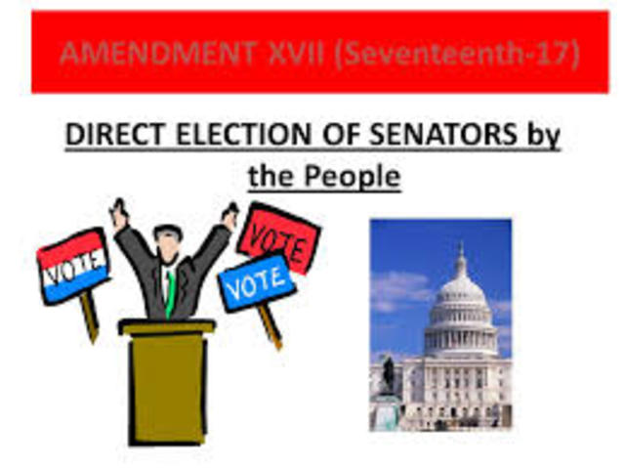As stated in Article I Section

**Amendment 18** - Prohibition, the manufacture, sale and transport of alcoholic beverages.

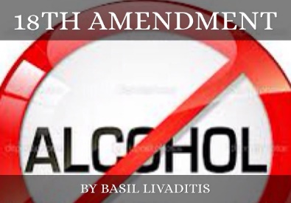

**Amendment 19** - Women’s suffrage

**This guarantees women’s right to vote in all federal, state and local elections.**

**It is often said that Seraph Young from Utah is the first woman in America to vote. She is the first woman in America to vote AFTER Amendment 19 was passed. In the beginning, woman voted in America if they were the head of the household and they were property owners. The same applied to men, they were the head of the households and they had to own property. Their vote was representing their family, not themselves.**

**Amendment 20** - Sets the dates at which federal government elected offices end and also defines who succeeds the president if the president dies.

**Amendment 21** -  Repeals the 18th amendment, and the prohibition of alcohol .

**Amendment 22** - President cannot run more than 2 terms

**Amendment 23** - Allows Washington DC to have electors to vote for President

**Amendment 24** -  Instituting the popular vote for President

**Amendment 25** - Allows the Vice President to become the President in the event of death, resignation, removal from office or impairment that prevents the current president from fulfilling his or her duties.

**Amendment 26** - Changes the voting age from 21 to age 18 yrs old.  During WWII, President Franklin Roosevelt lowered the minimum age for the military draft to 18 thus the slogan - “Old enough to fight, old enough to vote”.

**Amendment 27** - Prohibits any law that changes the salary of Congress from taking effect until following the start of the next election.