**2025 Freedom’s Light Constitution Bee Study Guide**

**Declaration of Independence**

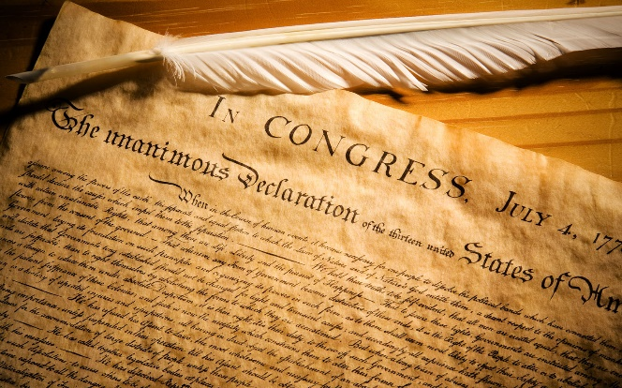

**What is the Declaration of Independence?**

Have you ever had to end a relationship or break up with someone? That is exactly what the Declaration did with England! It said, we are breaking it off with you King George III.

**What does the Declaration of Independence do?**

The Declaration of Independence is one of the most amazing documents in all of history!  Written mostly by Thomas Jefferson, this document (1) declares America was going to be an independent nation from England and would no longer be under the rule of King George III, (2) it gives the reasons they were declaring their independence, and (3) it lists their 27 grievances against the British government.

**Every principle in the Constitution is found in the Declaration.**

As Jefferson said, ”The law should restrain men from injuring one another but leave them otherwise free to regulate their own pursuits.”

**Why is it so important?**

The Declaration and Constitution are **based on the** **Laws of Nature and Nature's God**. The founders knew we needed our laws based on what they called “**right reason** aligned with nature”, based on a moral compass and based on a foundation that is universal, unchanging and everlasting, not determined by men’s passions.

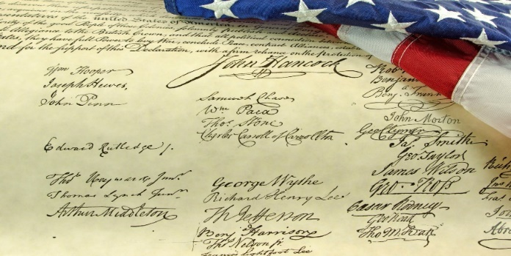

**What are the 8 principles of freedom and liberty that Jefferson put in the first 2 paragraphs of the Declaration?**

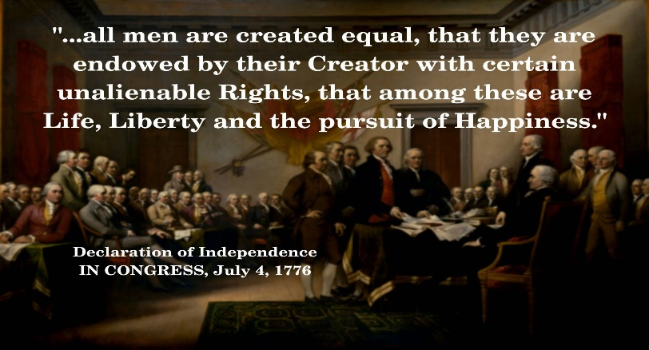

**The role of the government is to protect the rights of the people.**

**Each person is equal in rights, justice, value & protection**

**Rights come from our Creator**

**Rights are unalienable.**

**Each have right to life, liberty and property ownership**

**Self government**

**Established on the laws of Nature & Nature’s God**

**Founded on Self-evident truths**

**Power lies in the consent of the people (governed)**

Thomas Jefferson put the following passage in the original Declaration, but it was taken out because a couple of states that engaged in slavery REFUSED to sign with it in.

“He has waged cruel war against human nature itself, violating its most sacred rights of life and liberty in the persons of a distant people who never offended him, captivating & carrying them into slavery in another hemisphere or to incur miserable death in their transportation thither.He is now exciting those very people to rise in arms among us, and to purchase that liberty of which he has deprived them, by murdering the people on whom he has obtruded them: thus paying off former crimes committed again the Liberties of one people, with crimes which he urges them to commit against the lives of another.”

**According to the Declaration -**

What is the proper role of the Government?

**To protect the rights of the people.**

Who is supposed to govern us?

America is founded on **Self Government**.

Which people are entitled to special rights? All men are created equal, not the same, but equal in value & treatment.

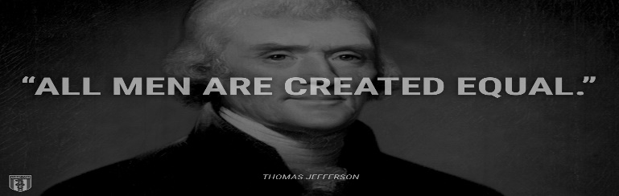

Who has the power to take our rights away? Because our rights come from the Creator, they are inalienable and can’t be taken without the offender coming under judgment of the Creator.

What are our unalienable rights? Most notable unalienable rights are Life, Liberty, and property ownership, pursuing one's personal mission and potential.

Who was the first to sign the Declaration and why? It was signed first by John Hancock, and he signed his name large enough so the King of England could read it without his spectacles!

The founders studied history, philosophy and the different forms of government that had been used to rule over people around the world. **They chose a Republic over all other forms of government including a democracy!**

According to the Declaration of Independence where do our rights come from? Our Creator. This is important because it is stating that since man does not give us our liberties cannot take them away without violating Gods law.

How many times does it mention God, the Divine Power or the Creator? 4 times.

*After the completion of the Constitutional Convention, Dr Benjamin Franklin was asked by Mrs. Powell who was standing near, “Well doctor, What have you given us, a republic or a monarchy?” Dr Franklin answered, “****A Republic, ma’am, if you can keep it.”***

What is the purpose of the Constitution? It is to **limit the powers of the Federal government**, and to **list the power it has specifically**.

Where is the ONLY place in the Constitution that the **federal** government requires the states (that created it) to do something & what is it? It is in **Article 4 Section 4.**  It **requires** every **state** to provide a ‘**REPUBLICAN**” form of government.

What are 2 things that bothRepublic and a Democracy can have in common? They are both ruled by the people, and both elect representatives.

What are the important **differences** between a Republic and a Democracy?



A Republic:

* is governed by the rule of law.
* has a written Constitution that protects the rights of every individual regardless of station or status.
* elected officials take an oath to uphold the Constitution, the rule of law.
* protects the minority so the majority cannot take away the unalienable rights of anyone.

A Democracy:

* is ruled by the majority of people, also known as “Mob rule.”
* only protects the rights of the majority, there is no protection for the rights of the minority.
* is rule by the majority so the majority has the power to take the liberties away from the minority.
* the individual or any group of individuals that are in a minority have no protection against the unlimited power of the majority.
* There is no need for an oath because the people are not ruled by law nor by principle, they are ruled by the changing feelings of the majority or mob.

## *The Preamble to the U.S. Constitution*

What is the Preamble? The preamble is a summary of the purpose of the Constitution and the intentions the Founders established for the people both then and now:

To form a more perfect union

To establish justice

To insure domestic tranquility

To **provide** for the common defense

To **promote** the general welfare

Secure the blessings of liberty to ourselves and our posterity

When a law is passed, the law makers should ask themselves, “Do I have a right to use force against my neighbor to achieve this goal? “Would I be willing to forcibly take his property, or lock him in jail for failing to obey this law? If not, he should vote against it.

**The 3 Branches of Government**

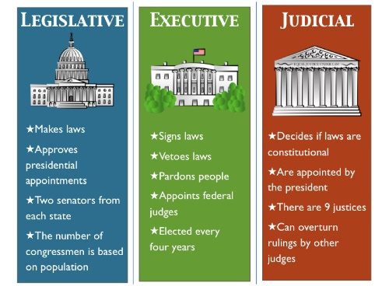

What is the role of the Constitution? **To protect the individual rights of the people.**

The genius of the Constitution is the principles in it, including **Federalism,** **the separation of power and checks & balances & more.**

What form of Government did the Founders create? A Republic, not a Democracy.



Who created the Federal government? **The States** created the Constitution & the federal government to protect the rights of every individual. It is the foundation of America’s guiding principles that created the most prosperous and free nation in the world.

It is the **supreme law of the land** by which the federal government is bound and government officials in every state are bound.

One of the most important founding principles of the Constitution is **Federalism!**

**What is Federalism?**  **It is the division of power between the states and the federal government. The powers of the Federal Government are FEW and DEFINED.**  They are very limited, and they are named or listed in the Constitution.

The Founders used Federalism to divide powers and ensure no one would have too much power making it harder to infringe on the rights of the citizens.

The Constitution says that any power NOT LISTED is a power of the States or the people.

**What are the federal powers and where are they found in the Constitution?** The 20 powers of Congress & the list of what they are limited to pass laws about, are in Article 1 Section 8.

The Executive Branch, Presidential powers, are listed in Article 2 Section 2 &3.

The Judicial Branch powers are in Article 3, Section 2.

**What is the benefit of Federalism for the states?** Another benefit is that each state has all the powers of the government **except the FEW & DEFINED that are listed**, so states have most of the power and could then do what was in their own best interest. Each state was to be its own laboratory in determining the best principles and ideas to see how they work. Also, it increases accountability of the local leaders to the citizens.[6](https://constitution.congress.gov/browse/essay/intro-2-2-3/ALDE_00000032/#ALDF_00014775)

Speaking of **Separation of Powers** ~ **Do you know where in the Constitution is the Separation of Church and State?**

Regardless of what you have heard, it is not in the Constitution anywhere! Amendment 1 states **“Congress shall make no law respecting an establishment of religion, or prohibiting the free exercise thereof…”**

**Where did that phrase come from then?** The phrase “separation of church and state” is nothing more than a comment made by Thomas Jefferson in a letter to the Banbury Church to reassure the members that there would not be a national religion. His statement was to assure them the government could not control religion. **Here is Jefferson’s letter. https://www.loc.gov/loc/lcib/9806/danpre.html**

Each state also has its own constitution to govern their state.

**How many articles are there in the Constitution?** The Constitution is divided into seven articles; each article covers a specific responsibility and power. If you want to have some fun, ask someone who is running for office, (and about to take an oath to uphold the constitution), how they feel about the 8th article, or do they have any issues with it? See what they say. Then you will know if they know enough about the constitution to uphold their oath to it.

**Why did the Founders want the powers of the Federal government separated & how did they do it?** They wanted to make sure no one had too much power! They lived under the tyranny of their King where one person had all the power & they wanted to be sure that could never happen again. 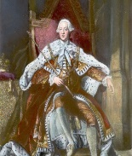

They sought to create a system that would limit the government’s power and protect the individual rights of the people.

They separated the power of the government by dividing power **at the National level** with the 3 branches and with Federalism**.**

Instead of allowing a single person, (like a king) a small group of people, (like an aristocracy or oligarchy) or the whole people (a democracy), they created a Republic.

**What is the principle of “separation of powers” & how was it implemented?** By **dividing** the federal **government into 3 branches,** each having very specific and different powers.

**This is good to study and know but we will NOT be asking any questions regarding the checks and balances in the Bee.**

**YOU DO NOT NEED TO STUDY THIS SECTION.**

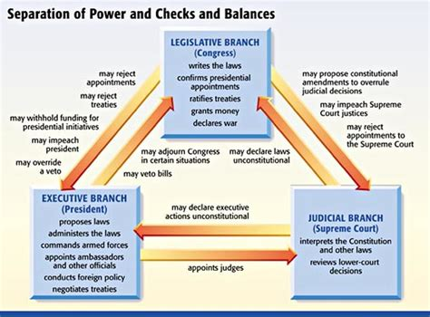

What are the “Checks and Balances” of the Constitution?

The Founders wanted each branch to be able to check and balance the powers of each other.

**What can the Legislative branch do to check the Executive Branch?** Only Congress can declare war, even though the Pres makes treaties and is the Commander in Chief.

The Legislative branch can override the veto with 2/3 votes.

The impeachment process gives Congress check & balance power over the other 2 branches.

Congress can impeach a judge for bad behavior so they can root out corruption and abuse of power in the other branches.

Congress has the power of the purse and can defund both of the other branches if they abuse their power.

**What can the Executive Branch do to check the Legislative Branch?** The President can veto a bill passed by the legislative branch.

The President can pick executive officers and enter treaties but they have to be approved by the Senate so they can check the President.

The President chooses Supreme Court judges but the Senate has to approve them, giving them power to check the Executive branch and the Judicial branch.

**What can the Judicial Branch do to check the other branches?** The judges are appointed, not elected so they never feel the pressure of the voters.

The Judicial branch can declare laws or presidential actions unconstitutional.

**_____________________________________________________________________________**

### Article I: Legislative Branch



What is Article I about? The legislative branch is known as Congress and is made up of the House of Representatives and the Senate.

This branch makes laws but only regarding **20 specific powers** granted to them. They are not to make laws regarding anything outside those 20 powers as listed in Article 1, section 8, clauses 1-18.

 

Congress is both the House of Representatives and the Senate.

**The House of Representatives** The House have 435 Representatives.

What is the job of Representatives and what are the qualifications? Members of the House are to **represent the people** of their states. They are elected by the people to represent them.

What are the qualifications to be a Representative? A person must be **25 years** old to serve in the House & been a citizen for at least **7 years** & live in the state they run to represent.

The term of office for members of the House is **two** years because the Founding Fathers wanted these representatives to answer to the people they represent frequently. After two years, the people have the power to elect new leaders if they are dissatisfied.

Which is the only body with power to impeach?

Only the House has the power to impeach a president.

The United States has 435 representatives.

How is the number of representatives from each state determined? By population and it changes depending on the population of the state. States with higher populations have more representatives.

If one state gains a representative, another state loses one.

(Fun facts: Seven states have only one representative: (Alaska, Delaware, Montana, North Dakota, South Dakota, Vermont, and Wyoming).

California has the highest number of representatives (52), down from 53 last year. This is the first time in California’s history they have lost a seat.

What if both the Pres and the Vice Pres were killed or died? The Speaker of the House presides over the House. He or she is the next in line behind the vice president to the succession of the presidency.

Members of the House vote to determine the Speaker of the House. No one can be sworn in until the speaker is elected.

Which branch of government does a bill regarding taxation have to start? The House of Representatives must start it.

If Congress wants to increase our taxes to pay for a “[freshwater mussel hatchery](https://twitter.com/DavidADitch/status/1503464225750007813)” which branch would it have to begin, the House or the Senate? All bills dealing with **taxes must originate in the House** because taxation affects people directly.

**The 3/5ths Clause**

**Most people do not understand the 3/5 Clause.** What would you do if you were a delegate for the Continental Congress? This is 1of the 3 issues Congress spent most of the time discussing & contending about. How to end slavery and how to be a united nation!

How is the number of Representatives determined from each state? Yes, by the population of the state!

If you were a delegate, what would you do to resolve this dispute? Delegates James Wilson and Roger Sherman proposed the 3/5ths clause.

**Article 1. Section 2. clause 3. is where the 3/5th clause is.**

**Why does the Constitution say slaves are counted as 3/5 of the population? Does that mean that some founders perceived slaves or blacks as being valued at 3/5 of a person?**

The number of Representatives is determined by population. The slave states wanted the entire slave population to count, giving them more Representatives; more votes in Congress. The anti-slave states did not want to increase the slave states power so they did not want to count the slaves in the population, which would give them more power.

Counting the whole number of slaves benefited the Southern states and reinforced the institution of slavery. Minimizing the percentage of the slave population reduced the population thus reducing the political power of slaveholding states.

Here is how it would shake out:

NORTH 3/5 Plan North Plan South Plan

Pennsylvania: 8 9 9

Massachucetta 8 7 7

New York 6 6 7

Connecticut 5 5 5

New Jersey 4 3 4

New Hampshire 3 3 3

Rhode Island 1 1 1

TOTAL 35 36 36

SOUTH

Virginia 10 9 15

North Carolina 5 6 8

Maryland 6 4 6

South Carolina 5 3 5

Georgia 3 1 1

Delaware 1 1 1

TOTAL 30 25 38

Can you see how the 3/5 plan protected the Nation from the slaves states having more power and it also included a tax of $10 per slave.

In 1787, the founders were attempting to form a union and preserve the United States. This compromise allowed for the United States to be preserved.

How would you have voted if you were a delegate?

**The Senate**

The United States has 100 senators.

How many Senators does each state have? 2 per state regardless of size or population.

Why does each state have the same number of Senators? Each state has **two** senators, regardless of population because the Senators job, according to the Constitution, was to protect each state from the federal government. The House were to represent the people by population and the Senate to represent each State so the size was irrelevant. This is how they got the small states and the big states to come together. They all got something they wanted but not everything they wanted.

Washington, DC does not have any senators because it is a city not a state as stated in the Constitution. Article 1 section 8 clause 17 states the federal government can only own 20 miles square, for the seat of the Government.

How long is the term of office for Senators? It is 6 years. They must be at least 30 yrs old & be a citizen for at least 9 yrs & live in the state they run to represent.

Who is the president of the Senate? The Vice Pres is the President of the Senate.

Does the VP vote on bills? Only if there is a tie. As there are 100 Senators, it is not unusual to have a tie on a vote.

According to the Constitution what was the role of a Senator? They were to represent the states, not the people and their responsibility was to act as a **sentinel to “protect** their states from the federal government and make sure the federal government does not take away the powers of the states.  They were not originally intended to represent the people as that is the job of the Representatives.

A law must be passed by both houses to become law.

Who is the only body with power to try a president, VP or Civil officer for impeachment? The House of Representatives is the only one with power to impeach, and the Senate is the only with the power to hold a trial and remove them from office.

When is the only time the Senate acts as a judge? The only time anyone acts as a judge, who is not a judge, is during an impeachment. Senators only function as judges during a presidential impeachment trial.

A presidential impeachment is an official hearing to investigate possible wrongdoing by the president. The Senate acts as judges to determine if there is enough evidence to convict and remove the official from office.

How many members must vote to convict to remove someone from elected office? It takes a vote by 2/3 of the members of the Senate present at an impeachment, to remove someone from office and prohibited from future service. They may also be tried by a civil or criminal court & receive additional penalties if they are found guilty of a crime.

**Article 1 Section 7**

Where must all bills regarding taxation originate & why? They must start in the House, because they are the body that represents the people. Who is more effected by taxes than the people!

**Article 1 Section 8**

What does the **General Welfare clause** & **Common Defense clause** do? They state that the federal government can **only** legislate regarding the enumerated or listed powers  **-**

**James Madison “ The powers delegated to the federal government are FEW and DEFINED.”**

Where are the 20 enumerated powers of Congress found?

**Article 1 Section 8 lists the Enumerated 20 powers of Congress:**

Tax and spend Pay the debts of the US

Power to borrow Regulate commerce

Establish postal system Pass copyright & patent laws

Establish federal courts Punish crimes on the high sea

Declare war Raise & finance armed forces

Establish rules to become a citizen Coin & regulate money

Standardize weights & measures Punish counterfeiting

Establish bankruptcy laws Call up militias

Administer the seat of the government Administer federal land

Congress is responsible for raising and supporting the Army and the Navy.

Pass laws to implement the above powers of Congress

Which is the only body of government that has the power to declare war & why? Congress is the only body of government that may **declare war** against another nation because they are a large body and their children would be the ones to go to war.

Can the President declare war as he/she is the Commander in Chief of the military? No, the Founders did NOT want one person to make such a heavy decision, they wanted the entire body of the House, that would be personally affected to have to decide together.

No state may declare war or enter into a treaty with another nation. The power to declare war and sign treaties is given to the federal government.

If Congress cannot meet, the executive branch has power to follow through on the federal government’s guarantee to protect each state against invasion.

According to the Constitution, how much land can the federal government own? Article 1 Section 8 Clause 17 says the Federal government cn only own 10 miles sq of the seat of the government, (now Washington DC) and Forts, Magazines, Arsenals, dockyards, & needful buildings.

What is the clause in Article 1 Section 8 clause 18 called? The Necessary & Proper Clause, often called the elastic clause.

What is the Necessary & Proper clause? It is a very important clause. It states that Congress, while they are limited to only pass laws regarding the 20 enumerated powers listed in Article I section 8, can also pass laws that are **necessary & proper** in order to fulfill, or carry out, those 20 enumerated powers listed.

Do you think that has been abused?

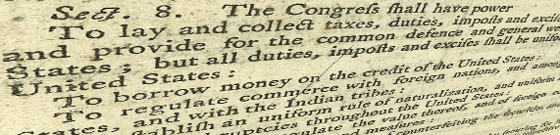

**What does Article 1 Section 9 do?** It states that importing slaves must end by 1808. Noone can bring slaves into America anymore!

The Founders wanted & needed to get the Constitution passed **unanimously** or we would not have a country, and all the lives lost at war would be for naught. Most of the Founders wanted to end slavery but 2 states didn’t & wouldn’t sign if slavery was ended. Article 1 Section 9 was an attempt to get the constitution passed and end slavery in 20 yrs. It says that importing slaves could not be banned by Congress before 1808, & they thought it would naturally end when no one was able to import slaves but unfortunately that didn’t happen. In order to make importing slaves less appealing they also imposed a tax of up to $10 per person. (Slavery was finally banned by the 13th amendment.)

The Founders attempted to end slavery by limiting importation of slaves in the year 1808 & by taxing slavery.

States do not have the power to do any of the 20 powers that are given to Congress, without the consent of Congress

**Article 1 Section 10 limits the powers of the states.**

**Article II: Executive Branch**



### What is Article II about? Article II is the Executive branch of the U.S. government



Who is in the Executive branch? The executive branch consists of the president, vice president and his or her cabinet.  Their responsibility is to enforce the laws.

What is the power of the Executive Branch? Their responsibility is to enforce the laws.

How long does the Pres and V Pres serve in a term? The term of office for the president is four years.

In the original Constitution, how was the president elected? The president is elected by electors.

How long is the term of office for the President and V President? The term of office for the president is four years.

How was the President elected in the original Constitution? The Founders created the Electoral College to choose a president.

Why did the Founders think the Electoral College was a superior way to elect the President over the popular vote?  The founders did not want ANYONE to run to be the president. They did not want anyone to seek this office. They wanted electors who represented the people to submit names of the best people to choose from. The original constitution did not include the popular vote to elect the President.

In fact, did you know that originally, no one could RUN to be the president? Each state elects delegates, electors, to go to the Electoral College. The number of electors is the total of all Representatives and Senators combined. Originally, the electors submitted, to the US Congress, the names of 2 people they thought had good character and would be an honorable president.

Then the Senate president (Vice President) counts all of the Electors votes and the person with the most votes becomes the president.  This is a summary of the process, and it has been changed many times over the years.

The president is elected by electors, not the people.

Each state elects delegates to go to the Electoral College.

Can a candidate win the popular vote of all individuals in the United States but still lose the election based on the electoral vote?  **Yes, The number of electoral votes always determines who the president will be**, regardless of the popular vote. They did not want high population cities or states to determine who the president was without input from the smaller states.

Did you know that if we used the popular vote without the Electoral College, the 10 most populated states could determine the outcome of the Presidential election? Because more than half of the population of the entire United States live in 10 states, they could always choose the president. The Founders did not want to have a small group or minority of people take over the elections, they wanted to have representatives from all across the nation choose the President.

What are the reasons the Founders created the Electoral College instead of a democratic popular election?   The president was to represent the nation and national interests.

They did not want someone to seek the office of president &  they were confident the electors would choose an honorable, qualified person.

The founders were concerned a tyrant would be able to manipulate the public opinion and get into power. They felt that when people of honor submitted names of other people of honor that would be a safety shield against tyrannical leaders.

The founders also believed that because the Electoral College was a group that met only once they would not be able to be manipulated over time.

What are the qualifications to run for President? The president must be a natural-born citizen.

Why was that important to the Founders? The Founding Fathers felt someone born a citizen would be more likely to have the interests of the United States at heart. They wanted to protect the nation from foreign influences or from anyone who would have other allegiances.

One must be at least 35 years old to serve as president of the United States, and have lived in America for 14 consecutive years.

Who is the commander in Chief of the U.S. Army and Navy? The president is the commander in Chief of the military.

How long is the term of office for a president? It is 4 yrs and originally there was no term limit, but the 22nd Amendment changed it to up to 2 terms.

If the president dies, who becomes the president? The vice president may serve for the remainder of the president’s term in office and may still be elected to serve up to two additional terms, if the time remaining in the original president’s term was less than two years.

Can the President, Vice President or civil Officers ever be removed from office? They can only be removed by impeachment of Congress & conviction of Treason, Bribery or other high crimes.

Remember, the **House charges** them with impeachment, then the **Senate holds the trial** and decides if they should be removed from office.

When is the only time the senators acts as judges? Impeachment is the only time the Senators acts as judges.

### Article III:  Judicial branch

What is Article III about? Article III is the judicial branch & made up of judges appointed to the Supreme Court. 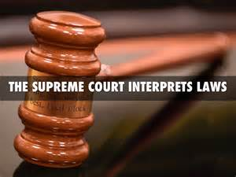

Who appoints the Judges? The president chooses a candidate to be a judge and then the Senate has a hearing to decide if they will give consent. A Supreme Court judge is appointed by the President and then approved by the Senate.

What does the Supreme Court do? Their job is to interpret the law and make sure it is aligned with the Constitution. They may declare acts of the executive or legislative branches to be unconstitutional.

How long does the Constitution say is the term of office for a Supreme Court judge? The constitution states that a judge holds his or her position during good behavior. That may be for life, depending on the judges behavior.

When is the only time a citizen does NOT have a right to a trial by jury? Every citizen has a right to a trial by jury, except in cases of impeachment. Trial by jury is an important check on the federal government. It protects citizens from tyranny by the federal government by placing power in the hands of the people instead of government officials.

       Requirements to run for each office:

**Representative**                        **Senator**                        **Pres & V Pres**

       Age          25 yrs old                           30 yrs old 35 yrs old

       Term            2 yrs         6 yrs                                      4 yrs

       Live in US     7 yrs        9 yrs               14 yrs & born in the USA

**Article IV: State and Federal duties**

**What is Article IV about?** Article IV explains the duties of cooperation of the states with each other and with the federal government.

It defines states powers. States do NOT have rights. Rights are endowed by the Creator to individual people.

States and businesses are created by man and given powers, not rights.

It ensures cooperation between the states when sharing public records, extraditing criminals and honoring the laws of the other states.

**What is the only thing the Constitution requires the states to do? The only place in the Constitution that requires states to do ANYTHING is in Article IV Section IV. It requires each state to provide a Republican Form of Government.**

**It also states it is the federal governments’ responsibility to protect each state against invasion.**

New states may receive admission into the union with approval from Congress

No state may be created inside another state.

Two states may not merge together to make one state or divide itself without Federal approval and the Federal government can’t divide a state or join states together without states approval.

**Article V:  The Amendment Process**

**What is Article V about?** Do you think the Founders thought we might need to make changes to the Constitution? They thought we might! That is what Article V is all about! It explains the right of the people to change the Constitution by using the amendment process and lays out 2 ways it can happen.

If you were to propose a change to the Constitution, or an Amendment, what would you propose? What if we proposed making it illegal to assign homework? Or required everyone to eat ice cream everyday?

Would that be one of the 20 powers listed in Article 1 Section 8? NO! But if it were, how would one go about making it an amendment?

How many ways are there to make changes to the Constitution & what do we call it? There are 2 ways in the constitution to make changes to it and we call it an Amendment. There are 2 ways to change the Constitution. The 1st method, (the one used for every amendment passed so far) is Congress proposes an amendment & if 2/3 of each the House and the Senate vote for it, they present it to the states. Then each state decides whether or not they want to ratify it and if ¾ of all the states vote for it, it becomes an amendment and is added to the Constitution.

This makes it so even a minority of states can stop an amendment from being passed.

The 2nd way is if all the state legislatures apply to Congress to call a convention for proposing amendments. If an amendment is approved, it has to

be sent to the states for ratification and must be passed by ¾ of the states to

be added to the Constitution.

Although this method has never been used, several states, including Utah, have passed legislation to propose amendments.

 How many Amendments are there? There are 27 AMENDMENTS in all, but we have only changed to constitution 17 times. How is that?

The first 10 are the BILL OF RIGHTS. **Important point!** These amendments, The Bill of Rights, DID NOT CHANGE the Constitution, but made clear the rights & principles already in it.A close-up of an old document

How many times have we changed the Constitution? We have changed it 17 times.

**Article VI: The U.S. Constitution is the supreme law of the land.**

What **is Article VI** about?It states the Constitution is the supreme law of the land.

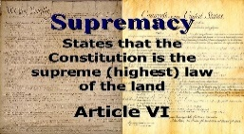

That means any **laws Congress passes** or anything the **President or a judge does is invalid if it does not align with the Constitution**. The Constitution is the supreme law.

What if Congress passed a law that everyone had to laugh every Sunday? Would that law be valid? Is that a power that is listed in Article 1 Section 8? No. Is the law supreme to the Constitution, or is the Constitution supreme to the law passed by Congress? The Constitution is supreme so the law would be invalid.

What if Congress passed a law that no one could use marijuana? Does Congress have the power to pass that law? Is it in Article 1 Section 8? The only power Congress has over drugs is if it is a national security issue and in the Commerce Clause so the federal gov can only regulate it if it crosses state lines. Congress did pass that law but is it valid? No, many states have Nullified that law stating the Constitution is supreme and does not give them power to regulate people’s use if it does not cross state lines.

Can states pass laws to make its use illegal? Yes, states have the power to pass such a law as Utah has.

**Remember, the Constitution protects the powers of the states and the people.**

Article VI also states that any debts already incurred before the ratification of the

Constitution are valid & honored by the U.S.



The Revolutionary War was expensive and brought a great deal of debt.

Can you imagine being in so much debt you feel like you will never be able to pay it back?

Did the Founders think that because their new country was in so much debt from the war & since we were starting a new country anyway, that we should not pay our prior debts?



The Founders felt it was a matter of **national honor** and **natural law** for the US to meet its financial obligations, so they voted to pay the debts of all the states. They felt it was a matter of **public morality.** They also felt that the respectability of the country was at stake.

They also knew that debt is bondage & can only be paid by bringing in taxes.

Debt has a very negative effect on national prosperity & once debt is incurred it is easy to continue to take on more debt and harder to preserve the limits imposed by a free constitution.

Can states or the President make treaties? No. Neither states nor the President can make treaties! All treaties must be voted on and passed by Congress. All treaties must be made in pursuance of, or in alignment with, the Constitution and under the authority of the US. The President negotiates treaties and Congress votes on them.

What are Judges bound to do? They are bound to uphold the Constitution by taking an oath. 

**What are all federal and state Senators, Representatives, Legislators, executive officers**

**and judges required to do? They must all take an oath to uphold the Constitution, not their own conscience.**

There cannot be a religious test required as a qualification to hold any office..

**Article VII:  Ratification Process .** 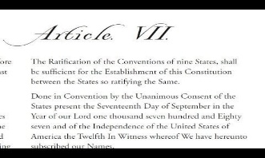

**What is Article VII** about? It tells the requirements to ratify the Constitution. That means they vote to approve it. The ratification process is the official approval and acceptance of the Constitution. It simply states the Constitution may be ratified or approved when 9 of the 13 colonies in the Constitutional Convention voted to approve it, but they really wanted every state to accept and ratify it so we would be a united nation.

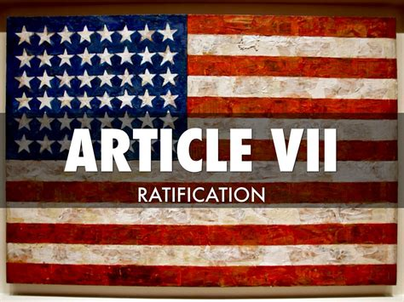

The federal government uses the same process to approve a state joining the union.

The Constitution was **ratified** by the necessary **9 states on Sept 17, 1787** but was ratified by all **13 states** when **Rhode Island finally signed on in May 1790.**

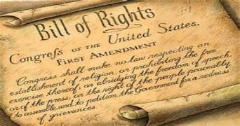

The Bill of Rights (the 1st 10 amendments) was ratified in 1791.

The Bill of Rights is **NOT** a **list the rights of the people**. The founders knew they could never list all our rights

and did not want to risk leaving anything off and not have it protected.

**It IS a list of the specific rights the federal government CANNOT restrict**

**nor pass laws to restrict.**  It guarantees protection from the federal

government of those specific rights and makes clear the limitations on the federal government. .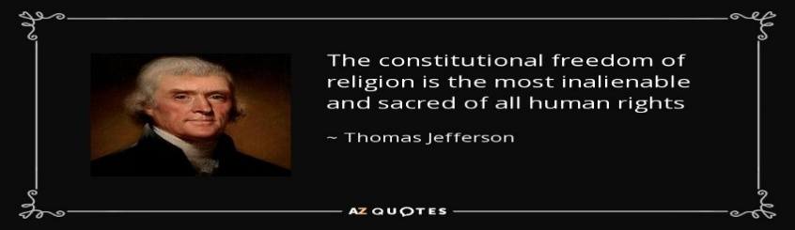

**Are you ready? Practice with your Mom or Dad! You (and they) will be inpressed with how much you know!**